News-Based Inflation Risk and Price Dynamics in Africa: Evidence from a Panel VAR
CAPE Economic Research and Consulting
May 2026
Abstract
Inflation surveillance in Africa is constrained by reporting lags and sparse high-frequency statistics. We construct the African Inflation Risk Index (AIRI), a rule-based, fully traceable measure of inflation risk extracted from domestic news corpora for 46 African economies over 2015–2025. Articles are screened for economic relevance, assigned an ordinal severity tier and a confidence weight, and aggregated to country-month level normalised by total corpus size, so larger media sectors do not mechanically register higher risk; each index value decomposes to the articles and matched terms that produced it. Using a Mean Group panel VAR with heterogeneous Granger causality tests, we find the first lag of AIRI predicts next-period inflation after conditioning on inflation persistence, exchange rate depreciation, money growth and output growth. The relationship is strongly state-dependent: concentrated in high-inflation economies and the 2022–23 global inflation episode, and weak in low-inflation regimes and quieter periods, consistent with attention-dependent expectation formation. Clark–West tests detect incremental predictive content up to six months ahead, though realised forecast gains over macroeconomic benchmarks are marginal. AIRI offers a transparent, near-zero-cost signal that is most informative where conventional data are weakest and inflation risk highest, complementing rather than substituting for official statistics.
Keywords: Inflation forecasting; News-based indicators; Panel VAR; Africa
JEL: E31, E37, C33, O55

1.0 Introduction
Inflation prediction has been central to macroeconomic management over the years, and the accuracy of the methods employed is key to the strength of policy intervention. Yet approaches to investigating the drivers of inflation have mostly relied on backward-looking data produced with a lag (Orphanides 2001). The drivers explored are typically GDP, money supply and interest rates (Malope et al. 2026). These series can take months to publish, denying policymakers the ability to act in time. The challenge is particularly pronounced in Africa, where data infrastructure is weaker (Jerven 2013) and institutional limitations make these needs difficult to address.
Surveys have been introduced as proxies for lagged measurement. The most prominent of these, the Michigan Survey of Consumers and the Survey of Professional Forecasters, have been evaluated for forecasting performance and rationality (Thomas 1999), but they carry structural delays and are mostly monthly, reflecting sentiment gathered over preceding weeks rather than current conditions. The same pattern holds in Africa: the Central Bank of Nigeria’s Inflation Expectation Survey (2025) samples thousands of businesses and is likewise monthly. Such instruments cannot track rapid shifts in inflation dynamics as they occur.
Machine learning offers higher-frequency alternatives, though with mixed success. Nakamura (2005) found neural networks outperformed autoregressive benchmarks for US CPI at short horizons, while Choudhary and Haider (2012) found the ranking reversed across countries. The deeper limitation is interpretability: these models are characterised as black boxes because, although they capture complex nonlinearities, they do not reveal what drives their predictions (Araujo and Gaglianone 2023). For institutions that must justify decisions publicly, a signal that cannot be explained cannot easily be acted upon.
A parallel literature turns to textual information. Shiller (2017) argues that media narratives are themselves economically consequential, shaping collective expectations; news frames the perception of economic agents and influences their decisions (Tetlock 2007) while anchoring expectations of future trends (Carroll 2003). Baker, Bloom and Davis (2016) operationalised this in the Economic Policy Uncertainty index, and the approach has since extended to GDP (Elshendy and Fronzetti Colladon 2017) and to social media measures tracking realised inflation and survey expectations (Angelico et al. 2022). Critically for a resource-constrained continent, news is continuous, near-costless, and requires no statistical infrastructure to collect (Buell et al. 2021).
This literature nonetheless remains concentrated in advanced economies. The EPU index covers fewer than fifteen African countries, and the World Uncertainty Index (Ahir, Bloom and Furceri 2018) relies on standardised international reports rather than domestic corpora. The closest continental attempt (Salisu, Salisu and Salisu 2024) is single-country. No measure provides inflation-specific risk coverage across African economies, and no study has tested whether such signals precede realised inflation on the continent using panel methods. The gap matters because African economies exhibit exactly the conditions under which narrative signals should be most valuable: high inflation volatility, rapid exchange rate pass-through, weak expectation anchoring, and severe constraints on official statistics.
We address this gap in two steps. First, we construct the African Inflation Risk Index (AIRI), a news-based measure designed to be traceable, monotonic and comparable across countries with differing media volumes. Articles are screened through a dictionary-based economic relevance filter following lexicon-based approaches to economic and financial text (Shapiro, Sudhof and Wilson 2020), assigned an ordinal severity tier according to how strongly an issue is framed as threatening, and weighted by signal credibility. Scores are summed over the inflation-tagged subset and divided by total article count for the country-period, so larger media sectors do not mechanically register higher risk. Because construction is rule-based rather than estimated, every value decomposes to the articles and terms producing it, directly addressing the black box limitation above. Second, we test the index across 46 African countries over 2015–2025 using a Mean Group panel VAR, heterogeneous panel Granger causality tests, and out-of-sample forecast comparisons against autoregressive and macroeconomic benchmarks.
Three findings emerge. The first lag of AIRI predicts next-period inflation after conditioning on inflation persistence, exchange rate depreciation, money growth and output growth, and non-causality is rejected for the panel. The relationship is strongly state-dependent. It is concentrated in high-inflation economies and the 2022–23 inflation episode, and weak or undetectable in low-inflation regimes and quieter periods, a pattern consistent with attention-dependent expectation formation. Forecast evidence is more measured: tests appropriate to nested models detect incremental predictive content up to six months ahead, but realised error improvements over the macroeconomic benchmark are marginal. AIRI is therefore a transparent, near-costless complement to official statistics, most informative where conventional data are weakest and inflation risk highest.
The remainder of the paper proceeds as follows. Section 2 reviews the literature. Section 3 describes the data and the construction of the AIRI, the panel VAR specification, and the forecast evaluation framework. Section 4 presents results. Section 5 concludes with policy implications.

Literature Review

2.1 Expectations and the Limits of Realised Price Indices
Conventional inflation measurement relies on realised price indices, the Consumer Price Index and related measures, which record price changes only after they have occurred. This backward-looking character creates a structural information gap: the expectations driving pricing decisions are invisible to statistical agencies until they have materialised in observed transactions (Mishkin 2007). Knight (1921) and Keynes (1936) established that economic decisions are governed by forward-looking beliefs rather than realised outcomes, and Friedman (1968) and Phelps (1968) formalised this by anchoring inflation in expectations, a dimension price indices cannot capture.
The empirical consequences are well documented. Mankiw and Reis (2002) and Sims (2003) showed that information disseminates slowly across agents, generating systematic gaps between actual and expected inflation. Coibion and Gorodnichenko (2012, 2015) demonstrated that these gaps are predictable and persistent, while Coibion et al. (2023) provided experimental evidence that inflation expectations independently alter household behaviour even absent contemporaneous price changes. D’Acunto et al. (2022) confirmed that subjective beliefs drive firm pricing strategies, establishing that the expectation-formation process causally precedes the price dynamics that indices eventually record. Forward-looking inflation surveillance therefore requires access to the information environment in which expectations form, not merely the price records that result.

2.2 Inflation Forecasting: Methods and Evolution
The evolution of inflation forecasting methods cannot merely be described as a movement from simple to more complex approaches, but rather a sustained search for the most effective and accurate approach as theory, data and computation evolved. Starting with the Phillips curve, whose explanation of inflation rests on the unemployment gap, Phillips (1958) found an inverse relationship between unemployment and the rate of change of wages in the United Kingdom. Samuelson and Solow (1960) applied the approach to the United States and found the same inverse relationship between unemployment and inflation. Friedman (1968), however, argued that the relationship was unstable, positing that it worked only because workers and firms were assumed not to form expectations about future inflation. The expectations-augmented Phillips curve was subsequently introduced to address this concern, formalised empirically through the Non-Accelerating Inflation Rate of Unemployment (NAIRU), the unemployment rate consistent with stable inflation. The structural approach was further challenged by the Lucas critique of econometric policy evaluation (Lucas 1976), which used the Phillips curve as its central illustration of how estimated relationships break down when agents adjust their expectations.
Following the Phillips curve’s breakdown in the 1970s and failed replication attempts, Galí and Gertler (1999) argued that the failure stemmed from using the wrong measure of slack. By replacing the output gap with real marginal cost, they were able to restore the inflation relationship. Atkeson and Ohanian (2001) later compared the forecasting performance of NAIRU-based Phillips curve models against a naïve benchmark and found that none of the Phillips curve forecasts was more accurate than the naïve alternative.
In response to the limitations of structural models, Sims (1980) proposed the Vector Autoregression, a less theoretically dependent and more data-driven framework, modelling macroeconomic variables jointly using their own past values rather than imposing structural restrictions. Stock and Watson (2001) applied a three-variable VAR of unemployment, interest rates, and inflation to US data and found it to be an effective forecasting tool. Cooley and LeRoy (1985), however, critiqued Sims (1980) for an identification problem, arguing that the VAR had hidden structure despite being presented as atheoretical. Sims himself acknowledged its constraint to a small number of variables, a problem he called profligate parameterisation.
Extensions that followed include the Structural VAR, which added identification restrictions to improve interpretability (Blanchard and Quah 1989); the Bayesian VAR, which imposed discipline on coefficient estimates through priors (Litterman 1986); and the Factor-Augmented VAR, which enriched the information set with common factors extracted from large macroeconomic datasets (Bernanke, Boivin, and Eliasz 2005). Despite this evolution, Stock and Watson (1999) found that the simple autoregressive model performed as well as or better than many competing models across the G7 economies, and the AR model has since become the standard benchmark for inflation forecasting evaluations, as further established by Stock and Watson (2007).
Following the global financial crisis of 2008 and the rapid development of machine learning tools, these methods have been applied to inflation forecasting. Medeiros et al. (2021) forecast United States inflation using LASSO regression and random forest methods and report substantial accuracy gains. Neural network models were similarly applied by Chakraborty and Joseph (2017), who showed that this approach performs better at forecasting during periods of structural breaks. However, a major challenge with machine learning is its opacity: the main drivers of inflation cannot be readily identified, creating a tension between accuracy and interpretability. Gentzkow, Kelly, and Taddy (2019) note that models achieving strong forecasting performance through complex nonlinear relationships typically cannot explain what drives their predictions or why those predictions change over time, and argue for rule-based, interpretable construction where the output is intended for policy use.

2.3 News-Based Measurement as a Forward-Looking Alternative
Shiller (2017) identified news media as the primary channel through which economically consequential narratives propagate and shape collective expectations. Tetlock (2007), García (2013), and Nyman, Kapadia, and Tuckett (2021) confirmed empirically that news-based signals contain forward-looking information about market conditions, economic activity, and systemic risk. Baker, Bloom, and Davis (2016) operationalised this insight through the Economic Policy Uncertainty (EPU) index, showing that newspaper-based indicators are strongly associated with investment, employment, and output, and Angelico et al. (2022) extended the approach to social media, constructing real-time measures that track both realised inflation and survey-based expectations.
Applications to inflation specifically remain concentrated in advanced economies. Shapiro, Sudhof, and Wilson (2022) established the link between media narratives and price dynamics in the United States. In Norway, Larsen, Thorsrud, and Zhulanova (2021) used machine learning tools to demonstrate that media-reported topics are strong predictors of inflation. In Europe, Barbaglia, Consoli, and Manzan (2023) found that topic-specific sentiment indicators targeting inflation-related narratives substantially outperform both generic sentiment measures and standard AR benchmarks in out-of-sample forecasting, with predictive gains concentrated at horizons of three to six months. Their finding that topic-specific pillars outperform aggregate uncertainty measures motivates the pillar-level rather than aggregate architecture adopted here, and their horizon results inform the forecast horizons evaluated in Section 4.

2.4 Attention and the Conditional Value of Narrative Signals
Theory does not predict that narrative signals should be uniformly informative, and this distinction is central to the present study. Sims (2003) and Mankiw and Reis (2002) imply that agents economise on attention when the cost of inattention is low, and a subsequent literature establishes that attention to inflation is itself state-dependent. Coibion and Gorodnichenko (2015) show that forecast errors and expectation updating vary systematically with the inflation environment, and household-level evidence indicates that attention to prices rises sharply once inflation becomes salient (Weber et al. 2022; Korenok, Munro, and Chen 2022). Bracha and Tang (2024) similarly document that inflation attention responds nonlinearly to the level of inflation itself.
The implication for news-based measurement is direct. If narratives influence expectations through the attention channel, a media-derived inflation risk signal should carry predictive content precisely when inflation is high or volatile enough to command attention, and should weaken or disappear when it is not. Regime dependence is therefore not an anomaly to be explained after the fact but a prediction the theory generates in advance, and it is a prediction this paper evaluates explicitly by comparing predictive content across country groups defined by inflation history and across the 2022 to 2023 global inflation episode.

2.5 Inflation Dynamics and Data Constraints in Africa
Inflation dynamics in Africa differ from those in industrialised economies in ways that bear directly on measurement. Where demand-side pressures dominate in advanced economies, African inflation is substantially more exposed to supply-side shocks, principally large currency depreciations, global food supply disruptions, and climate-driven volatility in domestic agricultural output (Durevall and Sjö 2012). Inflation mechanisms and persistence also vary widely across the continent, particularly between resource-rich and non-resource-rich economies (Kelikume 2018; Phiri 2016), which implies that empirical work imposing common dynamics across countries risks averaging away the variation of interest.
These characteristics coexist with binding data constraints. Advanced economies increasingly draw on high-frequency administrative sources, whereas African monetary authorities remain largely dependent on the conventional Consumer Price Index (CPI), which is low frequency, subject to substantial publication delay, and insufficiently granular to capture the localised character of price shocks (Blinder et al. 2024; Yeboah, Agyei, and Korsah 2025). Long-run series are further limited in coverage and comparability. The combined effect is an environment in which conventional inflation-targeting procedures are difficult to operate and real-time policy response is constrained.
These constraints have motivated interest in higher-frequency digital alternatives. Text-mining and natural language processing methods, ranging from lexicon-based scoring to transformer models such as InflaBERT, have delivered nowcasting gains elsewhere using news and social media text (Allard, Teiletche, and Zinebi 2024; Nguyen et al. 2025), and the tone of central bank communication has been shown to affect inflation expectations in African settings (Odu, Aminu, and Ado 2024). Application within the African empirical literature nonetheless remains limited, with non-textual econometric approaches continuing to predominate (Yeboah, Agyei, and Korsah 2025). Existing continental work relies principally on official backward-looking data: Nguyen et al. (2017) employ a Global VAR to identify the drivers of inflation in Sub-Saharan Africa, and Alper, Hobdari, and Uppal (2016) investigate the heterogeneity of inflation dynamics across income groups in the region. The closest news-based attempt, Salisu, Salisu, and Salisu (2024), constructs an economic policy uncertainty index for Nigeria from newspaper text, but is confined to a single country.

2.6 Panel Econometric Methods for Heterogeneous Macroeconomic Panels
Extending news-based inflation analysis from single economies to a continent-wide panel raises estimation issues the existing literature has not had to confront. The heterogeneity documented in Section 2.5 is the first. Pesaran and Smith (1995) show that pooled estimators applied to dynamic panels with heterogeneous slopes yield inconsistent estimates of average effects, since the bias does not vanish as the panel grows. Where dynamics plausibly differ across units, the Mean Group estimator, which estimates country-specific models and averages the coefficients, is the appropriate alternative. Panel VAR estimation itself follows the framework developed by Love and Zicchino (2006) and implemented by Abrigo and Love (2016).
Testing for predictive precedence across heterogeneous units requires comparable care. The pooled Granger causality test imposes a common null that is rarely appropriate in macroeconomic panels, and Dumitrescu and Hurlin (2012) develop a procedure that accommodates heterogeneous causal structures across units. Cross-sectional dependence poses a further threat: African economies are jointly exposed to global commodity prices, dollar funding conditions, and common shocks, and ignoring this dependence invalidates standard panel inference. Pesaran (2006, 2015) provides both a diagnostic test and the common correlated effects approach to estimation under such dependence.
Forecast evaluation raises a final and frequently misunderstood issue. Clark and West (2007) establish that conventional equal-predictive-accuracy tests are misspecified when the competing models are nested, as they are whenever a candidate predictor is added to an autoregressive benchmark, because the additional parameter introduces estimation noise under the null. The adjusted statistic they propose tests for incremental predictive information rather than realised improvement in forecast accuracy, and the two should not be conflated when reporting results. Section 3 sets out how each of these procedures is implemented.

2.7 The Gap
Three limitations therefore characterise the existing literature as it bears on Africa. First, news-based inflation measurement remains concentrated in advanced economies: the EPU index covers fewer than fifteen African countries, and the World Uncertainty Index (Ahir, Bloom, and Furceri 2018) is built from standardised international reports rather than domestic corpora, so it captures how African economies are described externally rather than the narrative environment in which domestic agents form expectations. Second, no existing index provides a pillar-level inflation risk measure with continent-wide coverage, and no study has tested whether such signals precede realised inflation across African economies using panel methods capable of accommodating heterogeneous dynamics. Third, the attention literature implies that the value of narrative signals should be conditional on the inflation regime, yet this prediction has not been tested in any setting where inflation regimes vary as widely as they do across the continent.
This gap is consequential because African economies exhibit precisely the conditions under which narrative signals should be most valuable: structural data delays, commodity-driven inflation, rapid exchange rate pass-through, weak expectation anchoring, and limited monetary policy credibility (Buell et al. 2021; Olamide, Ogujiuba, and Maredza 2022; Kasekende, Atingi-Ego, and Durevall 2018). The present study addresses it by subjecting the AIRI inflation pillar to panel econometric testing across 46 African economies, assessing whether the index contains incremental predictive information for realised inflation, whether that predictive content varies systematically across country groups defined by inflation history, and whether it improves the forecast performance of conventional macroeconomic models.

Methodology
This section attempts to formalize the evaluation of the predictive power of the AIRI inflation pillar. The Panel VAR is used to establish the statistical relationship between the lagged values of the AIRI and realized inflation and evaluate its predictive power across varying macroeconomic contexts (high and low inflation). The forecast evaluation checks if the AIRI inflation pillar improves forecast accuracy in models.

Data
We compute inflation risk as a decomposed component of the aggregate news-based index for Africa. The index captures inflation threats framed in newspaper narrative. The article-level scoring architecture used to derive the index includes economic relevance screening, ordinal severity tiering, confidence weighting, and multi-pillar mapping that identifies the inflation risk. By definition, the inflation risk index used in this paper is the normalised sum of article risk scores restricted to inflation-tagged articles, scaled to policy-friendly levels. The key characteristics of the index include monotonicity, non-negativity, and traceability, i.e. each contribution can be traced to a specific article, its matched dictionary term, severity tier, and weight component. Also, because the denominator is the total corpus size rather than the count of inflation articles, a country with more media output does not mechanically record more inflation risk, hence achieving volume comparability across countries.

Data Processing

Corpus Assembly.
All news articles are scraped for each country c at time period $t$, , and the total count of all articles, N_{c,t} = |I_{c,t}|, is used as the denominator, where I_{c,t} denotes the set of all articles retained for country c in period t. This allows for the anchoring of the pillar to the full corpus rather than just inflation-related articles, to ensure that the measure reflects the prominence of inflation narrative within the entire media landscape and comparison across countries with differing publication volumes.

Economic relevance screening.
R_{i} = 1{x_{i} matches ECON_RELEVANCE_TERMS}.
$R_{i}∈\{0,1\}$. Only relevant articles proceed to scoring.
Every article scraped is passed through a dictionary-based economic relevance filter. An article is tagged relevant if its concatenated title and body matched at least one term in the economic relevance dictionary ($R_{i}=1$); otherwise, it is assigned zero. This ensures that other news cycles, such as politics, sports, or crime, will not contaminate the inflation signal.

Inflation risk mapping.
Broadly, every relevant article is checked against the full set of risk pillar dictionaries defined in the AERI framework. Let p ∈ {1, ..., P} index the P risk pillars tracked by the framework (inflation risk, FX/external risk, debt/fiscal risk, and others), and let I_{p,i} ∈ {0, 1} indicate whether article i matches pillar p's dictionary. This assignment can be multi-label: a single article may simultaneously activate more than one risk pillar. Of the P pillars available, this paper isolates one: inflation risk.
Each article is checked against the inflation risk dictionary, with terms including consumer prices, cost-of-living pressure, price surges, currency-driven pass-through, and others. The indicator $I_{\text{inf},i}$ equals one when the article matches this dictionary and zero otherwise.

$$I_{\text{inf},i}=1\{x_{i}\text{ matches INFLATION_PILLAR_TERMS}\}$$

Severity tiering.
Articles receive an ordinal severity tier $S_{i}$ from 0 to 4 based on their relevance, reflecting how strongly the economic issue is framed as threatening. Dictionaries are tiered, escalating from mild concerns to extreme events through deterioration and crisis language. Non-relevant articles are fixed to zero severity.
S_{i} ∈ {0, 1, 2, 3, 4}, S_{i} = 0 if R_{i} = 0; otherwise S_{i} = max{matched tier in SEVERITY_TIER_TERMS}.

Confidence weighting.
A confidence weight $W_{i}$ is applied to reflect each article’s impact according to the credibility of its signal. The following features add to a baseline of one: a high-salience risk cue in the headline adds 0.5, because titles summarise editorial emphasis; body text exceeding a minimum length threshold adds 0.2, to capture substantive content; and activation of at least two pillars adds 0.3, indicating interconnected rather than isolated stress. The weight is capped at the interval $\left[1,2\right]$ so that no single unusually phrased article can dominate the aggregate.
$$W_{i}=\text{clip}\left(1+0.5⋅{\text{TitleHint}}_{i}+0.2⋅{\text{LongText}}_{i}+0.3⋅{\text{MultiPillar}}_{i}, 1, 2\right)$$
where ${\text{TitleHint}}_{i}$, ${\text{LongText}}_{i}$, ${\text{MultiPillar}}_{i}∈\{0,1\}$ are indicators for a headline risk cue, body length above threshold, and activation of at least two pillars, respectively, with
$${\text{MultiPillar}}_{i}=1\left\{\sum_{p=1}^{P}{I_{p,i}}≥2\right\}$$

Article-level risk score.
The article is scored by multiplying its relevance, severity, and confidence, which ensures logical consistency. Irrelevant articles contribute zero, and mildly framed relevant articles contribute little. Every score rises based on its severity and confidence. Because of this feature, every generated index is therefore traceable to observed textual features.
$$A_{i}=R_{i}⋅S_{i}⋅W_{i}$$
so that $A_{i}∈\{0\}∪\left[1,8\right]$: zero when irrelevant, and between 1 (Tier-1 severity, baseline weight) and 8 (Tier-4 severity, maximum weight 2) when relevant.

Aggregation to the country-period inflation risk index.
Inflationc,t=100⋅i∈ac,t​Ai⋅Iinf,iNc,t
Substituting the article score gives the fully expanded form:
Inflationc,t=100Nc,ti∈ac,t​Ri⋅Si⋅clip1+0.5⋅TitleHinti+0.2⋅LongTexti+0.3⋅MultiPillari, 1, 2⋅Iinf,i
To derive the index, article scores are summed over the inflation-tagged subset of the corpus, divided by the total article count for the country-period, and scaled by 100. This results in an average inflation risk intensity per article, which rises when inflation narrative becomes more frequent, more severe, and more credible, and is insulated from mechanical differences in media volume across countries.
To test the index derived, 46 countries (because of data limitation) from 2015 to 2025 were used to check the statistical relationship between the AIRI and realized inflation.

Empirical Analysis of AIRI: Stylized Facts on Inflation Risk vs. Inflation Rate Across Countries
This note presents the full set of stylised-fact charts comparing the AIRI inflation-risk indicator with headline CPI inflation across 46 economies, with an interpretation placed directly beneath each chart (or group of charts making the same point).

1. Country-Level Correlation Between AIRI and Headline Inflation
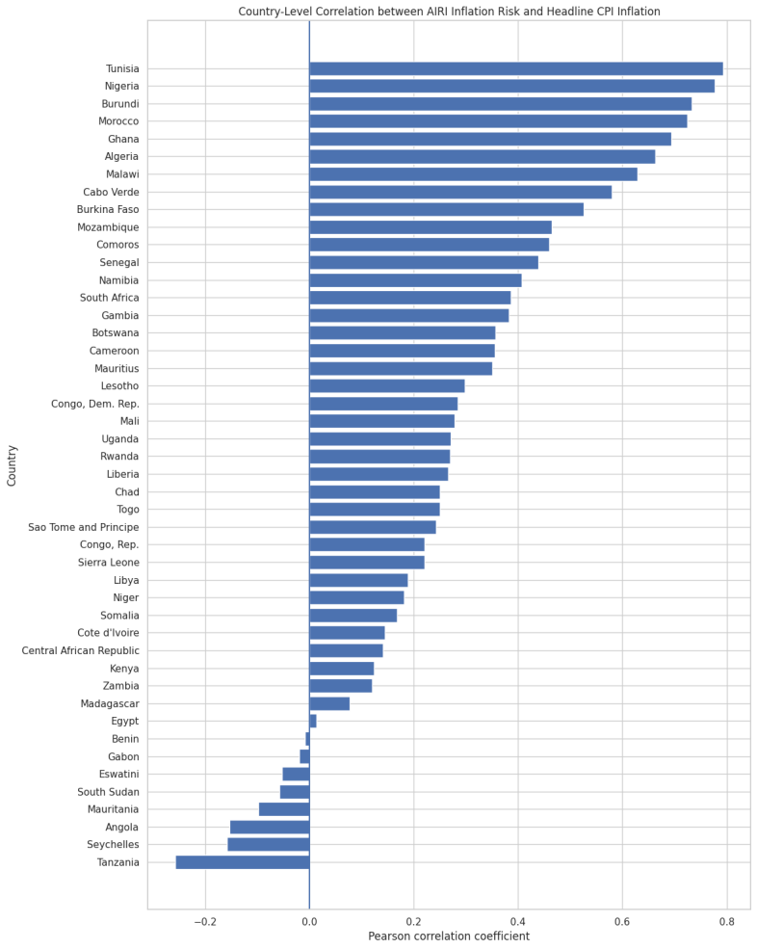
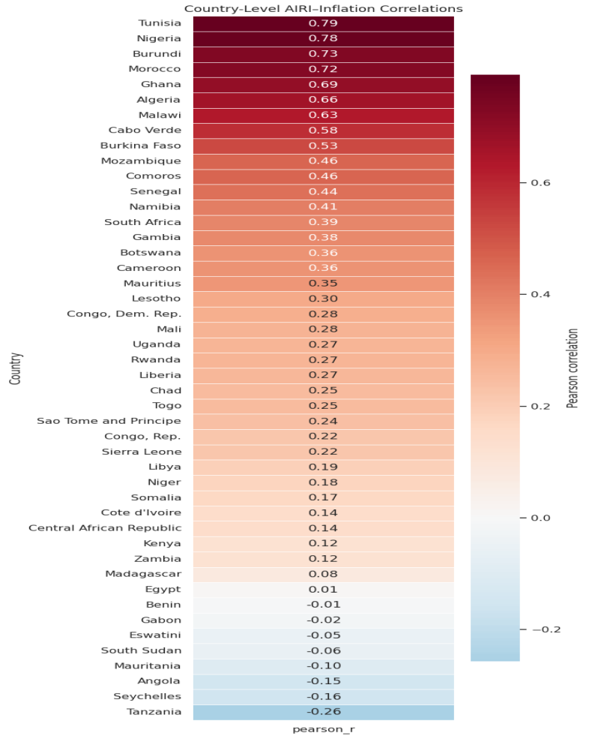
Figure 1a–1b. Country-level Pearson correlation between AIRI inflation risk and headline CPI inflation, ranked bar chart (left) and colour-coded heat map (right).
There is considerable cross-country variation. Tunisia (r = 0.793), Nigeria (r = 0.777), Burundi (r = 0.733), Morocco (r = 0.724), Ghana (r = 0.693), Algeria (r = 0.663), Malawi (r = 0.629), Cabo Verde (r = 0.580), and Burkina Faso (r = 0.526) show particularly strong positive relationships between AIRI inflation risk and realised inflation, meaning increases in the raw inflation-risk measure tend to coincide relatively closely with increases in observed CPI inflation in these economies. Across the full panel, the average country-level correlation is 0.281, and the median is 0.268; 38 of 46 countries (82.6%) show a positive relationship, and 32 are statistically significant at the 5% level. Only nine countries clear the “strong” threshold of r ≥ 0.50, while a handful of countries like Tanzania at r = -0.257, along with Seychelles, Angola, Mauritania, South Sudan, Eswatini, Gabon and Benin — show a negative or essentially flat relationship. In short, AIRI carries real signal about realised inflation in most countries, but its reliability is highly country-specific rather than universal.

2. Cross-Country Relationship Between Average Inflation and Average AIRI Risk
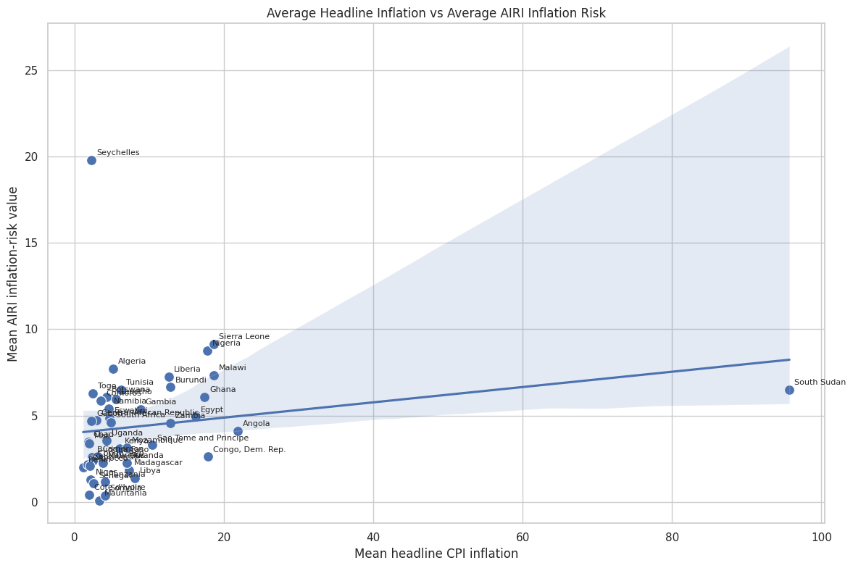
Figure 2. Mean headline CPI inflation versus mean AIRI inflation-risk value, one point per country, with a fitted regression line.
At the level of country averages, higher long-run inflation is associated with a higher average AIRI reading, but the fit is loose and is heavily influenced by a few outliers. Seychelles sits far above the line, combining a low mean CPI (around 4%) with an unusually high mean AIRI value (around 20), while South Sudan sits far to the right, with an extreme mean CPI (around 96%) but only a moderate AIRI reading (around 6.5). The other 44 countries cluster tightly in the lower-left corner, with mean CPI below roughly 20% and mean AIRI below roughly 10. This means the overall positive slope is driven disproportionately by a small number of extreme cases rather than reflecting a tight, general relationship between typical inflation levels and typical AIRI readings.

3. Distribution of the Pooled Panel
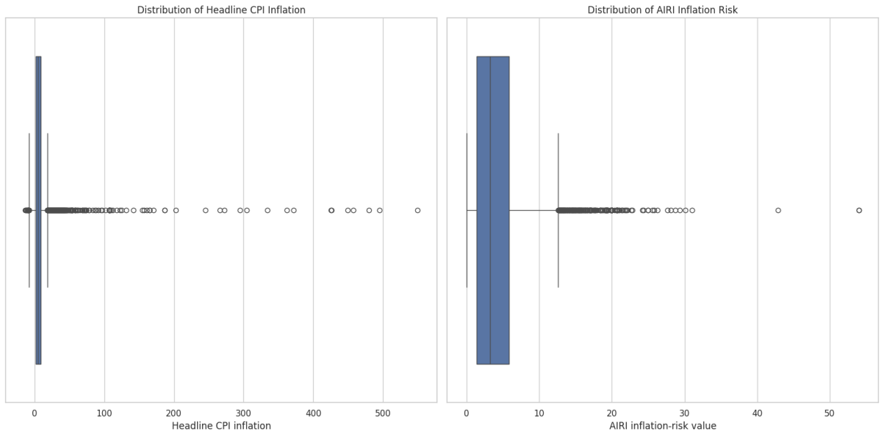
Figure 3. Box plots of headline CPI inflation (left) and AIRI inflation risk (right) pooled across all countries and time periods.
Pooling all country-month observations together, both series are heavily right-skewed. The interquartile box for CPI inflation sits close to single digits, but a long tail of outliers extends beyond 500%, driven chiefly by hyperinflation episodes such as South Sudan’s. AIRI risk shows the same shape on a more compressed scale: a narrow box roughly between 0 and 6, with outliers reaching above 50. Because both variables spend most of their time in a narrow “normal” range and are dominated in the tails by a small number of crisis episodes, the strength of the AIRI–CPI relationship in any given country depends heavily on how well those tail episodes line up between the two series, which helps explain the wide dispersion of country-level correlations seen in Figure 1.

4. Country-by-Country Spread of CPI Inflation and AIRI Risk
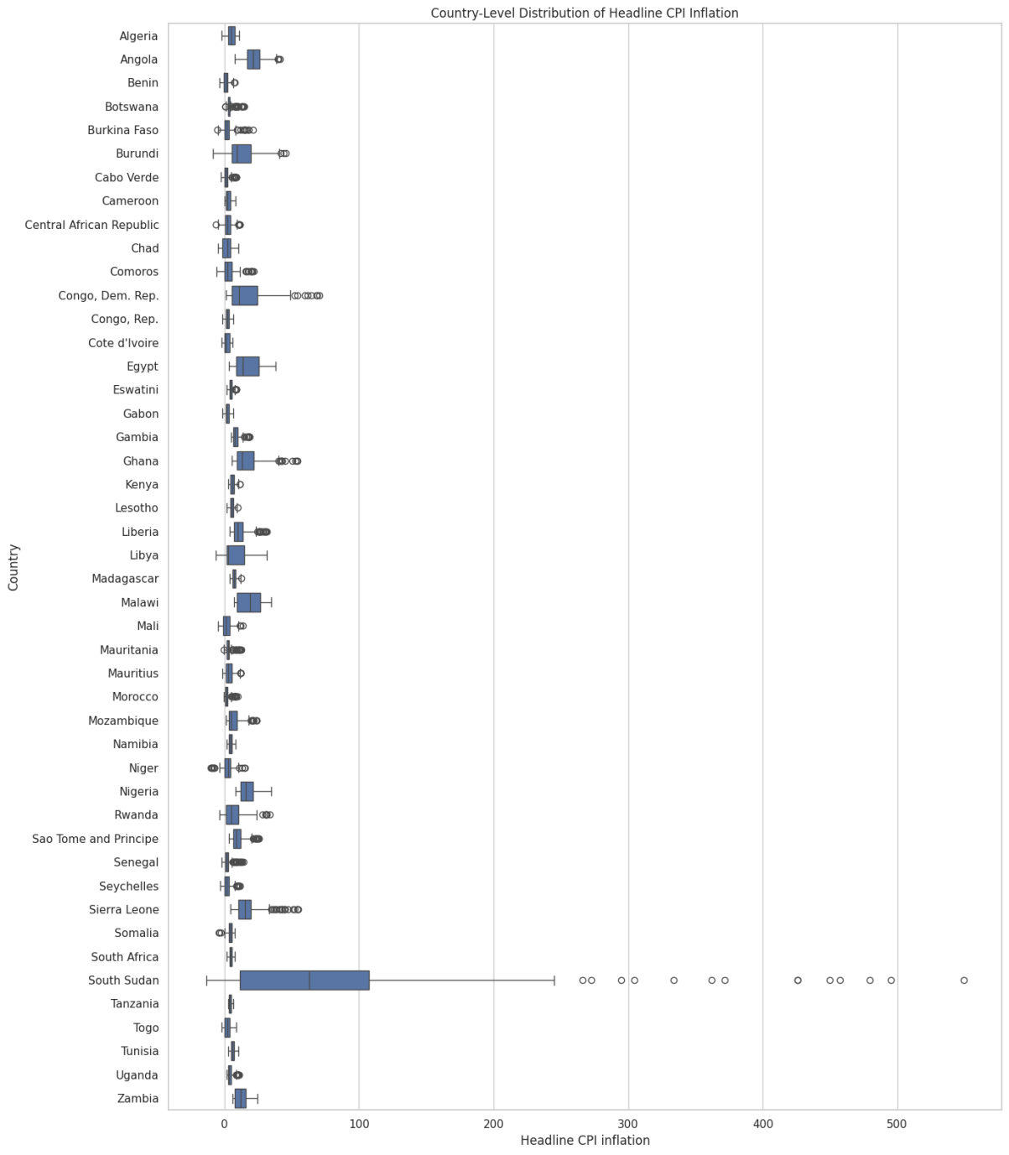
Figure 4a. Country-level distribution of headline CPI inflation.
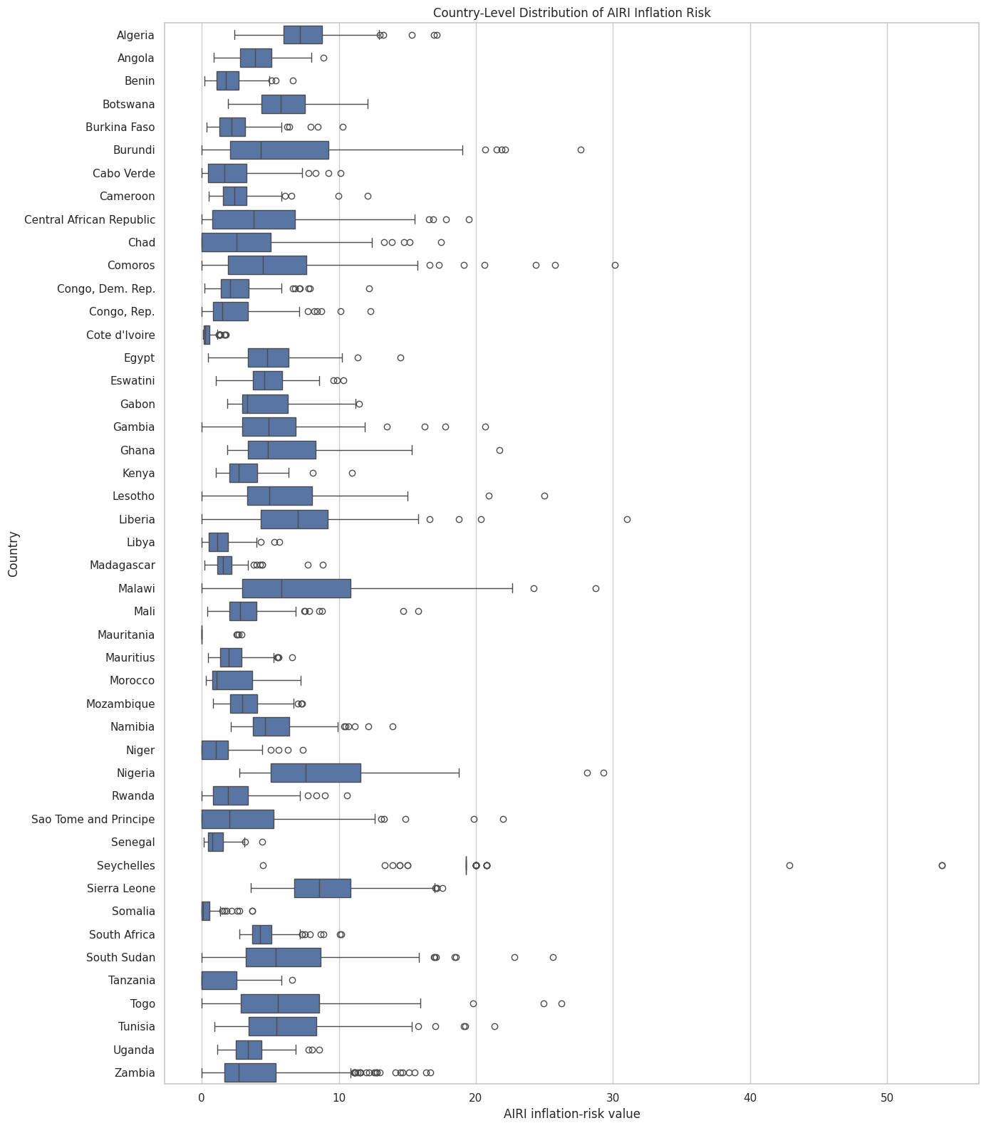
Figure 4b. Country-level distribution of AIRI inflation risk.
Breaking the pooled distribution down by country shows that extreme inflation is concentrated in a small number of economies. South Sudan is in a class of its own for CPI inflation, with a median above 50% and outliers beyond 500%, while most other countries have compact boxes below roughly 20–30%; Angola, Congo (Dem. Rep.), Egypt, Ghana, Sierra Leone and Malawi form a second tier of moderately high and volatile inflation. The AIRI distribution tells a related but not identical story: Nigeria, Sierra Leone, Malawi, Comoros, Liberia and Burundi display the widest AIRI boxes, and Seychelles has the single most extreme AIRI outlier (above 50) despite not standing out at all in the CPI chart; a further sign, consistent with Figure 2, that the AIRI measure and realised inflation can diverge sharply for particular countries.

5. Panel-Wide Trend Over Time
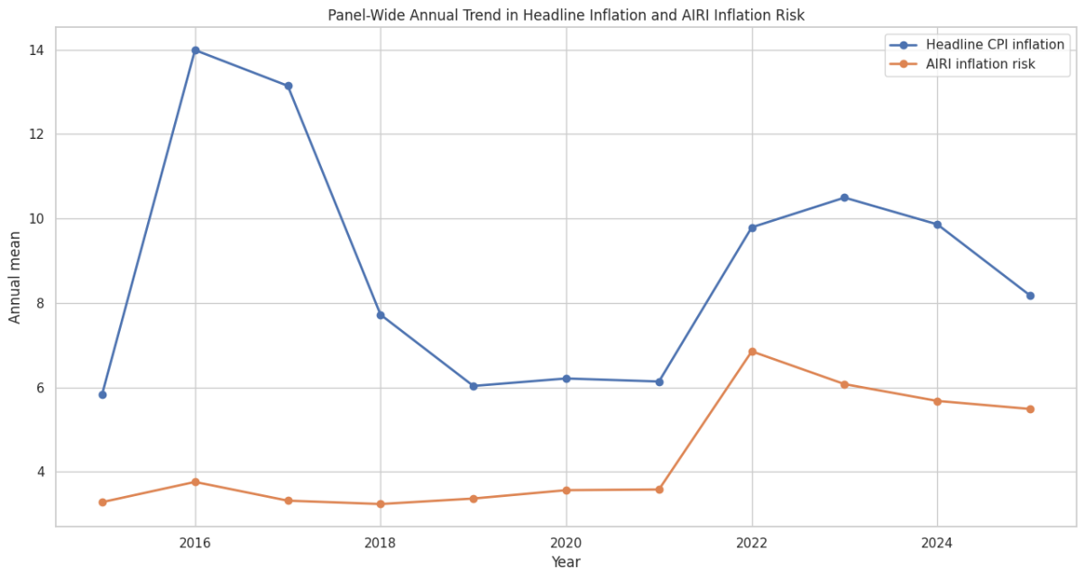
Figure 5a. Annual panel-wide mean of headline CPI inflation and AIRI inflation risk, raw units.
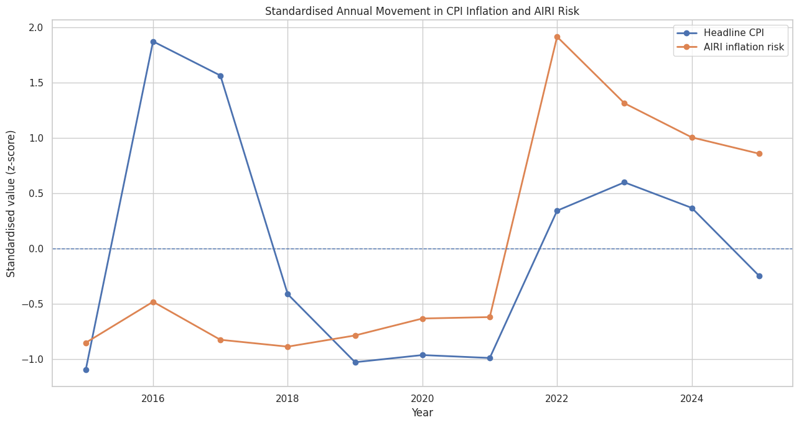
Figure 5b. The same two series expressed as standardised (z-score) annual movements.
The panel-wide annual averages trace two inflation cycles: a peak around 2016 and a much larger one from 2022 onward, following the global post-pandemic inflation shock, with a trough in between around 2018–2021. AIRI risk tracks the second episode much more closely than the first. In standardised terms, CPI jumps sharply in 2016 (z ≈ 1.9) while AIRI barely moves and is even slightly below its own long-run average (z ≈ -0.5); but in 2022 both series spike together, with AIRI actually showing the larger standardised move (z ≈ 1.9 versus 0.3 for CPI). After 2022, CPI falls back toward its historical average faster than AIRI, which stays elevated (z of roughly 0.9–1.3) through 2023–2025. This pattern suggests the AIRI measure was particularly responsive to the recent global inflation shock, but is more sluggish than realised inflation both in missing earlier, more localised episodes and in signalling the subsequent disinflation.

6. Countries Where AIRI Tracks Inflation Well versus Poorly
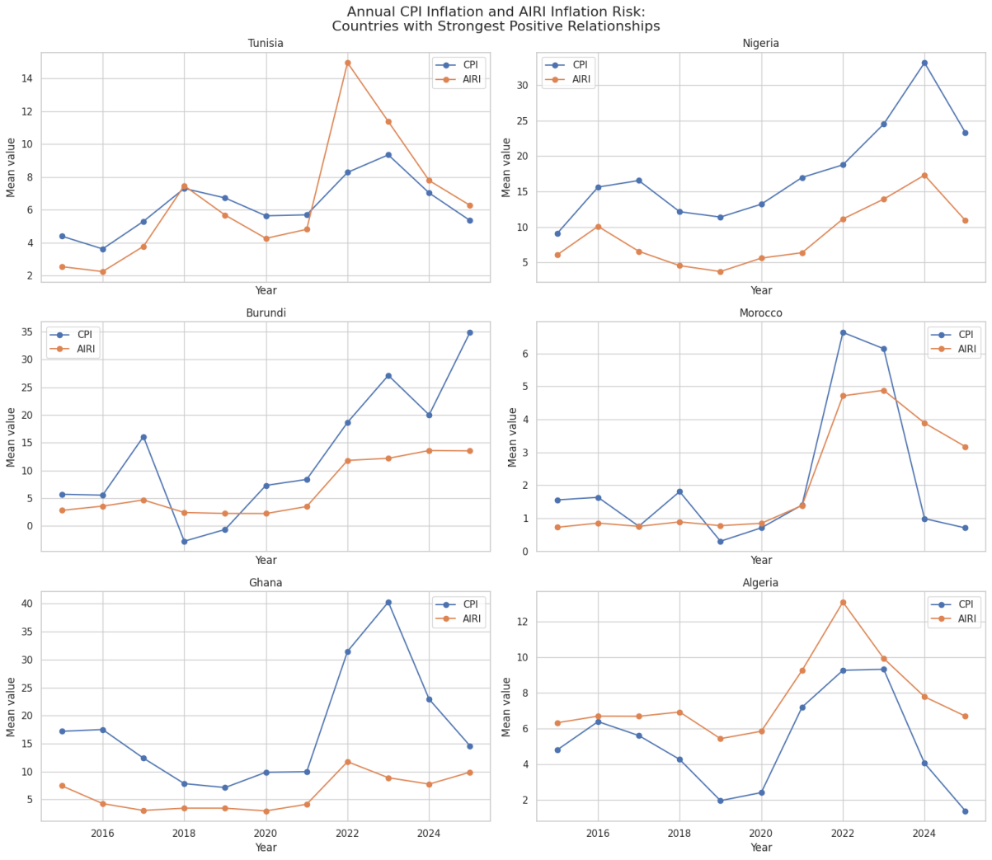
Figure 6a. Annual CPI inflation and AIRI risk for the six countries with the strongest AIRI–CPI relationship.
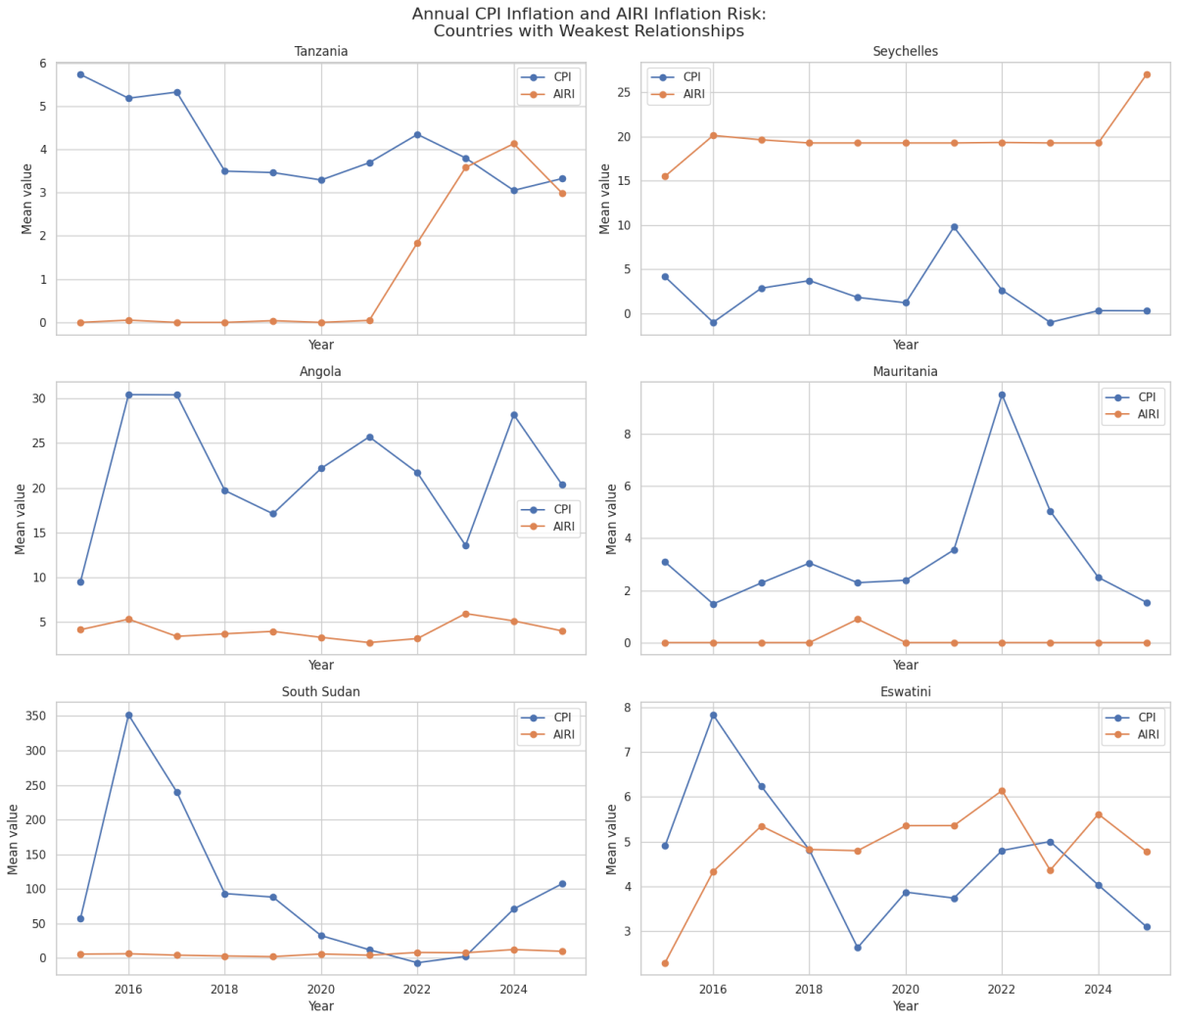
Figure 6b. Annual CPI inflation and AIRI risk for the six countries with the weakest AIRI–CPI relationship.
Contrasting the six strongest-relationship countries (Tunisia, Nigeria, Burundi, Morocco, Ghana, Algeria) with the six weakest (Tanzania, Seychelles, Angola, Mauritania, South Sudan, Eswatini) shows clearly where the aggregate correlation in Figure 1 comes from. In the strong-relationship countries, the two lines rise and fall together and share common turning points, most visibly around the 2022 spike. For example, Tunisia’s AIRI jumps to about 15 alongside CPI’s jump to about 8.4, and Algeria’s two series peak together in 2022 before declining together into 2025. In the weak-relationship countries, the series are effectively decoupled: in Mauritania and Tanzania, AIRI sits near zero for almost the whole sample regardless of what CPI is doing; in Seychelles, AIRI stays persistently high (18–20) while CPI oscillates mildly between about -1% and 10%; and in South Sudan, CPI swings wildly — from roughly 350% in 2016 down to near zero and back above 100% by 2025 — while AIRI barely registers any movement. This suggests AIRI behaves more like a slow-moving structural risk signal in some countries, one that can become almost uninformative, or even move independently of, realised inflation when that inflation is driven by idiosyncratic shocks, currency collapse, or conflict.

7. Shape of the AIRI–Inflation Relationship in the Top Countries
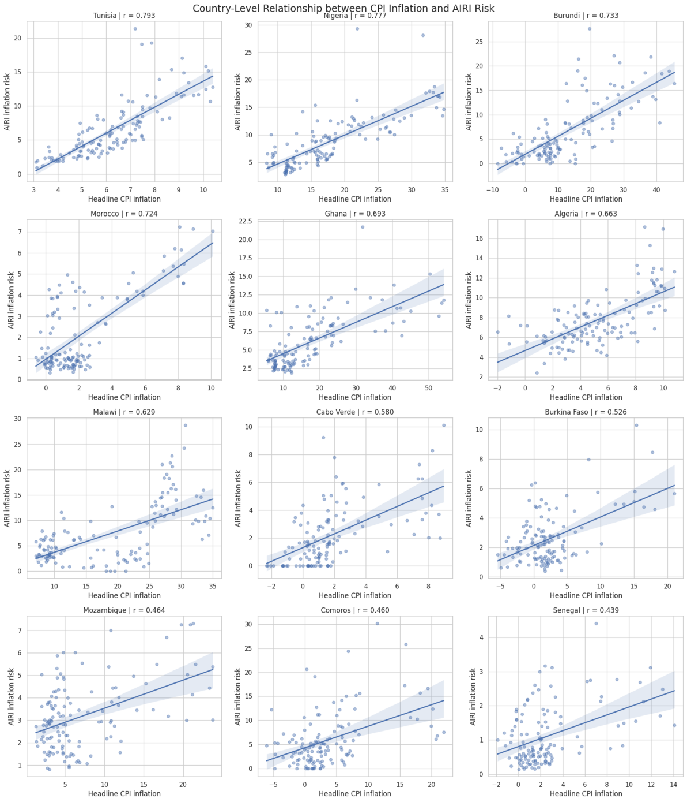
Figure 7. Country-level scatter plots of AIRI risk against headline CPI inflation, with fitted regression line, for the twelve countries with the strongest correlations.
Looking at the underlying scatter of monthly observations rather than the single correlation coefficient in Figure 1, shows that even the “top 12” countries differ in how reliable their relationship is. Tunisia, Nigeria and Morocco show a fairly linear, tightly banded relationship with narrow confidence bands around the fitted line, indicating a genuinely proportional co-movement. Others further down the ranking, such as Cabo Verde, Comoros and Senegal, show noisier clouds of points, often with many observations clustered near zero on both axes and only a handful of higher-inflation episodes pulling the regression line upward. This confirms that a “positive and significant” country correlation can reflect either a consistently proportional relationship or one driven mainly by a few extreme episodes within an otherwise flat pattern.

8. Volatility Comparison
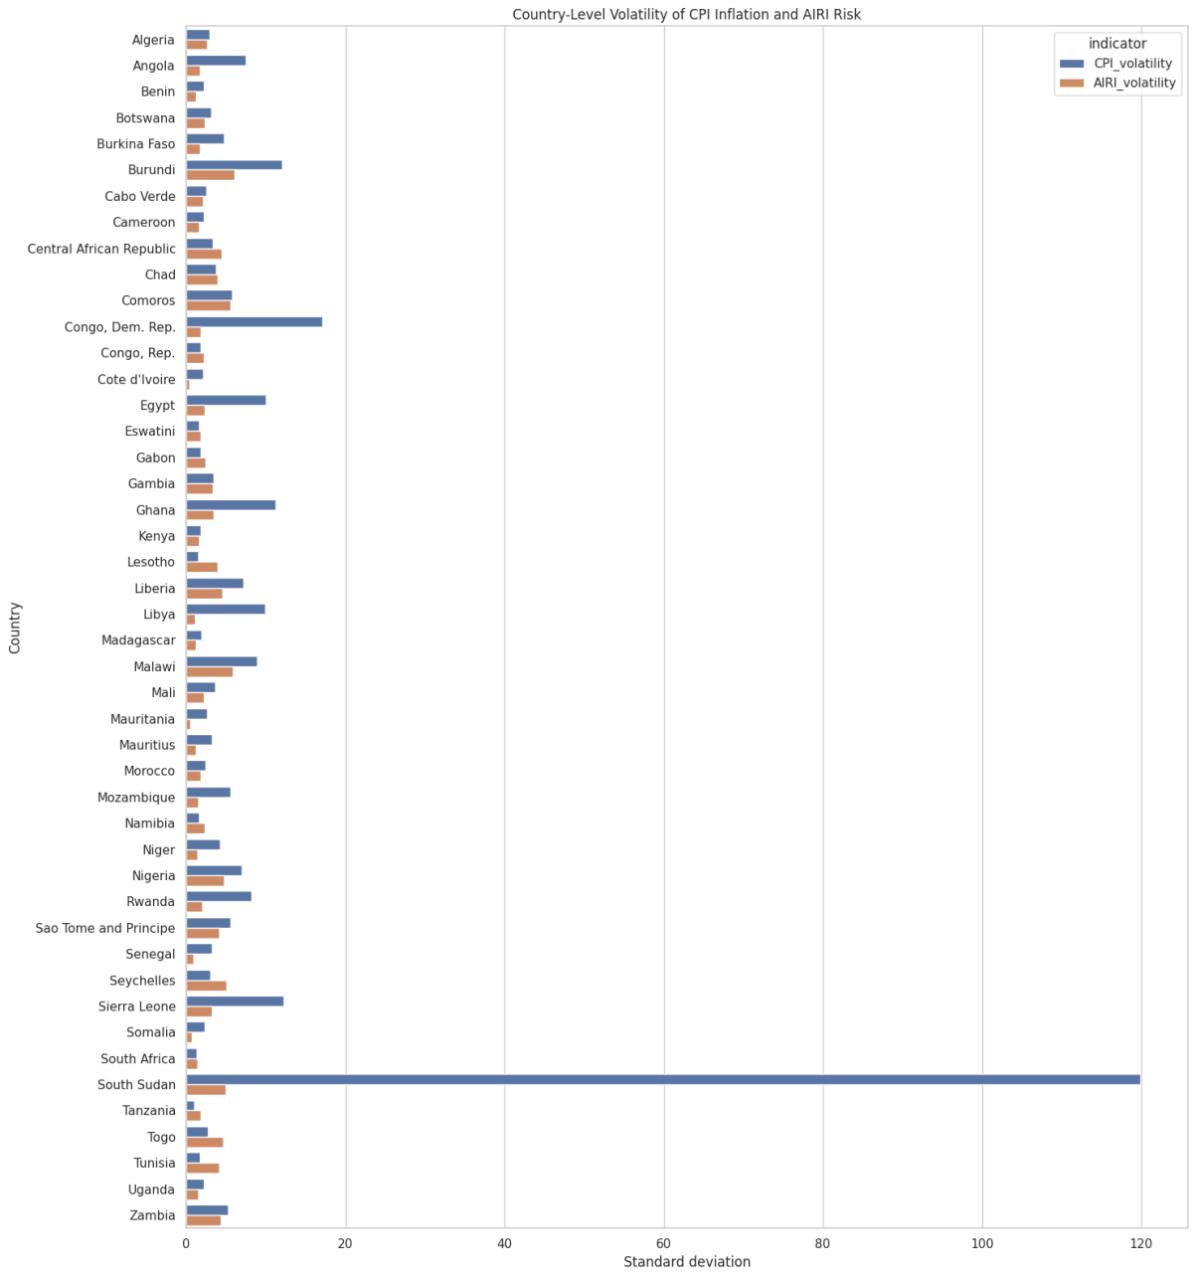
Figure 8. Country-level standard deviation (volatility) of headline CPI inflation versus AIRI inflation risk.
Ranking countries by the standard deviation of CPI inflation against that of AIRI risk shows that CPI inflation is, with virtually no exceptions, far more volatile than AIRI. The gap is most extreme for South Sudan, where CPI volatility (≈120) is more than twenty times AIRI volatility (≈5), but the same pattern holds for Congo (Dem. Rep.), Sierra Leone, Libya, Egypt, Ghana and Burundi as well. Because AIRI is a structurally smoother, lower-variance series than realised CPI inflation, it is mechanically unable to track the sharpest inflation swings even in countries where the two series are correlated on average, which is part of why even the strongest country correlations in Figure 1 still leave much of the variation in CPI unexplained.

9. Macroeconomic Correlation Matrix
 | m | delta_e | pi | airi_pi | g
m | 1.000 | 0.206 | 0.082 | -0.013 | -0.082
delta_e | 0.206 | 1.000 | 0.171 | 0.059 | -0.067
pi | 0.082 | 0.171 | 1.000 | 0.129 | -0.168
airi_pi | -0.013 | 0.059 | 0.129 | 1.000 | -0.048
g | -0.082 | -0.067 | -0.168 | -0.048 | 1.000
Figure 9. Pooled pairwise correlations between money growth (m), currency depreciation (delta_e), CPI inflation (pi), AIRI risk (airi_pi) and real GDP growth (g).
At the pooled macroeconomic level, money growth, currency depreciation, CPI inflation, AIRI risk and real GDP growth are all only weakly correlated with one another since no off-diagonal coefficient exceeds 0.21 in absolute value. Money growth and currency depreciation have the strongest pairwise link (0.206), consistent with standard monetary and exchange-rate channels of inflation, and inflation is negatively correlated with growth (-0.168), consistent with a growth–inflation trade-off. Notably, the correlation between AIRI inflation risk pillar and Headline CPI inflation at this pooled, cross-country level is only 0.129, which is much weaker than the 0.281 average correlation reported country-by-country in Figure 1.

10. Time-Varying (Rolling) Correlation
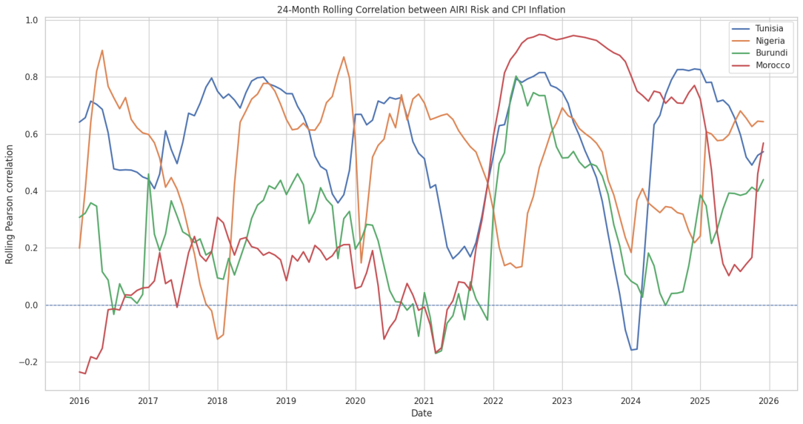
Figure 10. 24-month rolling Pearson correlation between AIRI risk and CPI inflation for Tunisia, Nigeria, Burundi and Morocco.
The rolling correlation shows that even for the four best-performing countries in the full-sample ranking, the AIRI–CPI relationship is far from stable through time. All four lines fluctuate substantially, occasionally swinging from above 0.8 to near zero or negative within a couple of years — Tunisia’s rolling correlation, for instance, falls to about -0.16 in 2024 before recovering above 0.8 by 2025. The clearest common feature is a broad convergence toward high correlation (roughly 0.7–0.95) during the 2022–2023 global inflation shock, when all four lines rise together; outside that window the countries behave much more idiosyncratically, at times differing from one another by 0.5 or more at the same point in time. This confirms that the AIRI–CPI relationship is regime-dependent: it strengthens markedly during large, common inflation shocks and weakens or becomes unstable in quieter periods.

11. Where AIRI Over- or Under-States Realised Inflation
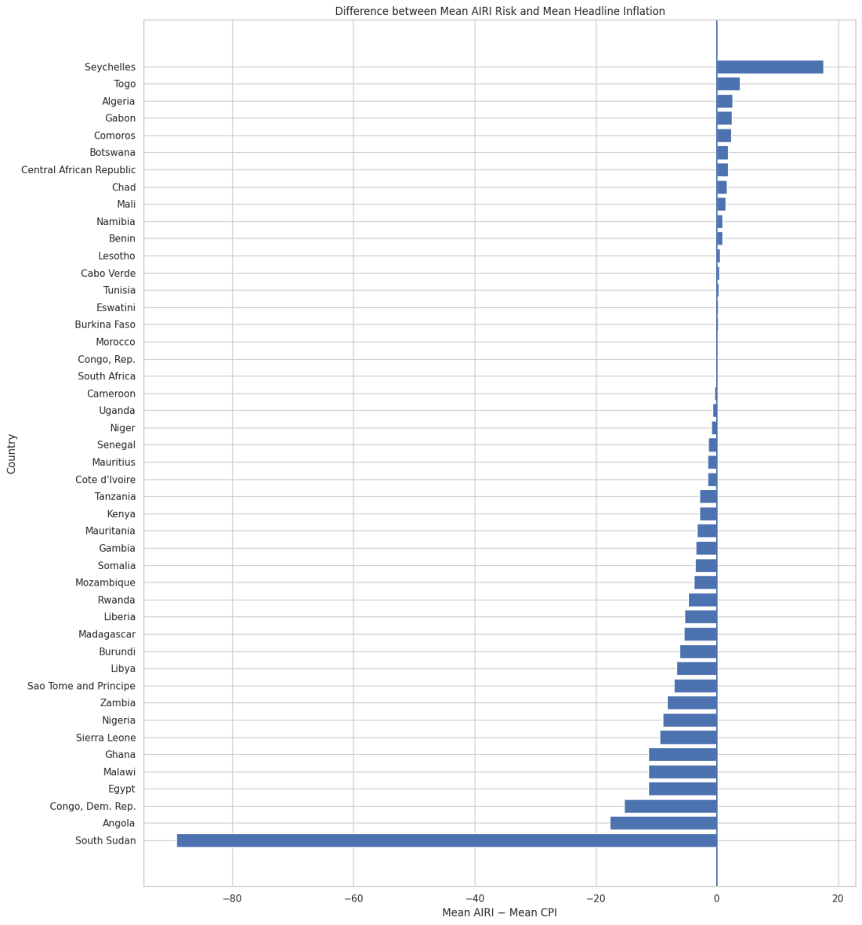
Figure 11. Difference between each country’s mean AIRI risk and its mean headline CPI inflation, ranked.
Ranking countries by the gap between mean AIRI risk and mean CPI inflation highlights differences in level, separately from the correlation results above. Seychelles is the only country where AIRI substantially overstates inflation relative to CPI, by roughly 18 points on average. At the other extreme, South Sudan, Angola, Congo (Dem. Rep.), Egypt, Malawi, Ghana and Sierra Leone all show AIRI running far below realised inflation, which is most dramatic in South Sudan, where the gap is about -90 points, reflecting hyperinflation episodes that the AIRI measure comes nowhere close to matching in scale. The majority of countries in the middle of the chart cluster close to zero, meaning AIRI and CPI are of a broadly similar order of magnitude in most “normal-inflation” economies, with the largest gaps concentrated in the same handful of extreme or crisis-affected countries that also stand out in Figures 2, 4 and 8.

12. Country-Level Summary
Metric | Value
Number of countries | 46
Average country-level Pearson correlation | 0.281
Median country-level Pearson correlation | 0.268
Countries with positive AIRI–CPI correlations | 38 (82.6%)
Countries with negative correlations | 8
Countries with statistically significant correlations (5%) | 32
Countries with strong positive correlations (r ≥ 0.50) | 9
Strongest positive relationship | Tunisia (r = 0.793)
Weakest relationship | Tanzania (r = -0.257)
Taken together, these headline statistics support an overall reading of the stylized facts above: AIRI carries genuine, statistically detectable signal about realised inflation in most economies (a positive relationship in 82.6% of countries, significant in 32 of 46), but that signal varies enormously in strength, is diluted once countries are pooled together, is structurally less volatile than realised inflation, and can weaken, become unstable over time, or break down entirely in a minority of countries with unusual inflation dynamics such as hyperinflation, currency crises, or conflict.

Panel VAR Methodology
To investigate whether the AIRI predicts realised inflation when other factors have been accounted for, we estimate a panel vector autoregressive model for all 46 countries in Africa. The Panel VAR captures the dynamic relationship between variables, considering all variables as endogenous. The estimation allows for the computation of the direction of the statistical relation through Granger causality. The response of realised inflation to changes in the AIRI will be computed by the Impulse Response Function (IRF).

Model Specification
Following Love and Zicchino (2006) and Canova and Ciccarelli (2013), the reduced-form Panel VAR of order $p$ is specified as:
$$Y_{n,t}=A_{0}\left(c\right)+\sum_{k=1}^{p}{A_{k}}Y_{n,t−k}+u_{n,t}$$
where $c=1,…,N$ indexes countries ($N=46$) and $t=1,…,T$ indexes monthly time periods (January 2015 to December 2025). $Y_{n,t}$ is the $5×1$ vector of endogenous variables:
$$Y_{n,t}={\left[\text{AIRI}π_{n,t},Δe_{n,t},m_{n,t},g_{n,t},π_{n,t}\right]}^{⊤}$$
where $\text{AIRI}π_{n,t}$ is the AIRI inflation pillar score for country $c$ at time $t$, scaled to the interval $\left[0,200\right]$ and normalised by total article volume, and $π_{n,t}$ is month-on-month headline CPI inflation. We identify other variables that have been tested in the literature to predict inflation, in order to account for factors that can influence realised inflation: $Δe_{n,t}$ is the month-on-month percentage change in the nominal exchange rate, local currency per USD (Razafimahefa 2012); $m_{n,t}$ is money supply (M2) growth (Okedigba et al. 2024; Alimi 2012); and $g_{n,t}$ is real GDP growth (Barnichon and Peiris 2007). All five variables are treated as endogenous, so each can respond to shocks in any of the others. $A_{0}\left(c\right)$ is a $5×1$ vector of country-specific intercepts, capturing the fact that countries differ in their average level of risk narrative and inflation regardless of dynamics. $A_{k}$ for $k=1,…,p$ are $5×5$ matrices of lag coefficients, and $u_{n,t}$ is the $5×1$ vector of reduced-form disturbances, with $E\left[u_{n,t}\right]=0$, $E\left[u_{n,t}u_{n,t}'\right]=Σ$, and $E\left[u_{n,t}u_{n,s}'\right]=0$ for $t≠s$.
Equation (11) imposes slope homogeneity: carries no country subscript, so the dynamic relationship among the five variables is assumed identical across all 46 countries, with only the intercept allowed to vary. Given the well-documented heterogeneity of inflation dynamics across Africa (Nsafoah, Dery, and Ilori 2025), this assumption is tested rather than taken for granted, following Pesaran and Smith (1995).$A_{k}A_{0}\left(c\right)$
We estimate two versions of equation (11). The first is a pooled fixed-effects Panel VAR: country intercepts are removed by within-group demeaning, and a single set of coefficients ${\hat{A}}^{FE}$ is estimated by OLS across the full panel.
The second is the Mean Group estimator (Pesaran and Smith 1995): a separate VAR of order is estimated by OLS for each of the 46 countries individually, and the coefficient matrices are averaged across countries:$p$
AkMG=N−1c​Akc
Mean Group places no restriction on $A_{k}$ across countries and remains consistent whether or not slope homogeneity holds, whereas the pooled fixed-effects estimator is consistent only if homogeneity holds.
The two sets of estimates are compared using the Hausman-type poolability test of Pesaran and Smith (1995):
$$H=\left({\hat{A}}^{MG}−{\hat{A}}^{FE}\right)'{\left[\text{Var}\left({\hat{A}}^{MG}\right)−\text{Var}\left({\hat{A}}^{FE}\right)\right]}^{−1}\left({\hat{A}}^{MG}−{\hat{A}}^{FE}\right)$$
which is asymptotically $χ^{2}$ distributed under the null of slope homogeneity. Rejecting the null indicates that the pooled coefficients are inconsistent and that the country-specific dynamics captured by Mean Group should be used for inference, including the causality test in Section 3.2.3, which relies directly on country-by-country coefficient variation.
Table 3: Variable Definitions and Data Sources
Variable | Definition | Source
$$\text{AIRI}π\left(c,t\right)$$ | AIRI inflation pillar score, country $c$, month $t$. Normalised by total article volume; scale 0–200 | Akande et al. (forthcoming)
$$π\left(c,t\right)$$ | Month-on-month headline CPI inflation (%) | IMF International Financial Statistics
$$Δe\left(c,t\right)$$ | Month-on-month change in nominal exchange rate, local currency/USD (%) | IMF International Financial Statistics
$$g\left(c,t\right)$$ | Real GDP growth (%) | World Bank WDI / IMF WEO
$$m\left(c,t\right)$$ | Money supply (M2) growth (%) | IMF International Financial Statistics

Pre-Estimation Diagnostics
Before estimation, each variable is tested for stationarity using the Im, Pesaran, and Shin (2003) panel unit root test, which allows the autoregressive coefficient to vary across countries and is therefore appropriate given the heterogeneity documented across the panel (Kelikume 2018; Phiri 2016). Where a series is non-stationary in levels, first differences are used and long-run relationships are assessed with the Westerlund (2007) panel cointegration test.
Cross-sectional dependence is tested using the Pesaran (2004) CD test, applied to the residuals of the estimated Panel VAR rather than to each variable’s raw univariate autoregression, so that the test reflects dependence remaining after the model’s own dynamics have been accounted for.

Granger Causality
To test whether AIRI statistically precedes inflation, a Granger causality test is carried out. The null hypothesis of non-causality from $\text{AIRI}π$ to $π$ is:
$$H_{0}:A_{k}\left[\text{AIRI}π→π\right]=0 \text{for all }k=1,…,p$$
Given the cross-country heterogeneity already established, the Dumitrescu and Hurlin (2012) test is used rather than a pooled panel Granger test, since a pooled test would impose a common causal coefficient across all 46 countries and understate the relationship in countries where it is in fact strong. The test computes a country-specific Wald statistic for each country and averages them:$W^{c}$
W=N−1c​Wc
Its standardised form is asymptotically standard normal under the null of homogeneous non-causality as $N,T→∞$. Rejecting the null establishes that AIRI carries predictive information for inflation beyond inflation’s own history—the paper’s central empirical claim, and one that does not depend on any of the identifying assumptions in Section 3.2.4.

Impulse Response Function (IRF) Analysis
Granger causality establishes whether AIRI predicts inflation, but not the size or duration of that relationship. Impulse Response Functions are used to trace the path of inflation following a one-time shock to AIRI (Canova and Ciccarelli 2013).
Because the reduced-form residuals $u_{n,t}$ are correlated across the five equations, a shock cannot be isolated to one variable without first imposing a causal ordering. A Cholesky decomposition of the error covariance matrix $Σ$ is used for this purpose (Love and Zicchino 2006), under the ordering:
$$Y_{n,t}={\left[\text{AIRI}π_{n,t},Δe_{n,t},m_{n,t},π_{n,t},g_{n,t}\right]}^{⊤}$$
This ordering reflects the speed with which each variable can plausibly respond within a given month: news-based sentiment ($\text{AIRI}π$) adjusts fastest and is unconstrained by administrative reporting; the exchange rate reprices within the day; money supply can adjust within the reporting month; headline inflation is released reasonably quickly (monthly CPI); and GDP growth is compiled last, with the longest lag and most revisions of the five. GDP growth is therefore allowed to respond contemporaneously to all four other variables, but a shock to GDP growth only feeds back into them with at least a one-month delay.
To ensure that the result is not an artefact of the ordering, we reverse the order to test for robustness:
$$Y_{n,t}^{alt}={\left[Δe_{n,t},m_{n,t},g_{n,t},π_{n,t},\text{AIRI}π_{n,t}\right]}^{⊤}$$
Structural IRFs are traced over $h∈\{1,2,…,12\}$ months, with 95% confidence bands constructed using panel-style block bootstrapping with 1,000 replications (Abrigo and Love 2016), which resamples whole country time series to preserve cross-sectional and temporal dependence.

Forecast Evaluation
This section seeks to establish the forecasting value of the AIRI inflation pillar. This is achieved through an out-of-sample forecast evaluation to test whether including the AIRI inflation pillar in a benchmark model improves forecast accuracy relative to benchmark models.
The forecast evaluation is structured around a nested model comparison. Three panel regression models are specified, each adding one additional layer of information. This enables us to trace any improvement in forecast accuracy to the specific change implemented in the new model, moving from the AR benchmark to a model that includes the AIRI inflation pillar.
The AR benchmark follows the proposition of Stock and Watson (1999) and Atkeson and Ohanian (2001) that the naïve method of forecasting inflation from its own past values is difficult to outperform, and should serve as the standard that any meaningful model must supersede. The model is specified as:
$$π_{c,t+h}=α_{c}+\sum_{i=1}^{p}{γ_{i}}π_{c,t−i}+λ_{t}+ε_{c,t+h}$$
where $π_{c,t+h}$ is inflation in country $c$ at horizon $h$ months ahead, $α_{c}$ denotes country fixed effects, $λ_{t}$ denotes time fixed effects, $p$ is the optimal lag length selected by the Bayesian Information Criterion, and $ε_{c,t+h}$ is the error term.
The macro benchmark extends Model 0 by incorporating a standard set of macroeconomic control variables—the nominal exchange rate, money supply, and GDP growth—known to influence inflation dynamics in African economies (A. D. M. Nguyen et al. 2017; Alper, Hobdari, and Uppal 2016):
$$π_{c,t+h}=α_{c}+\sum_{i=1}^{p}{γ_{i}}π_{c,t−i}+\sum_{j=1}^{J}{δ_{j}}X_{j,c,t}+λ_{t}+ε_{c,t+h}$$
where $X_{j,c,t}$ denotes the $j$-th macroeconomic control variable observed at time $t$ and $δ_{j}$ is its coefficient.
The AIRI model further augments Model 1 with the AIRI inflation pillar:
$$π_{c,t+h}=α_{c}+\sum_{i=1}^{p}{γ_{i}}π_{c,t−i}+\sum_{j=1}^{J}{δ_{j}}X_{j,c,t}+β⋅{\text{AIRI}}_{c,t}+λ_{t}+ε_{c,t+h}$$
where ${\text{AIRI}}_{c,t}$ is the AIRI inflation pillar observed at time $t$ and $β$ is the key coefficient capturing the incremental predictive contribution of AIRI for future inflation after conditioning on inflation persistence and the standard macroeconomic information set. A positive and statistically significant $β$ indicates that the AIRI inflation pillar contains genuine predictive information beyond what conventional macroeconomic variables already provide.
All three models are estimated separately at forecast horizons $h∈\{1,3,6,12\}$ months using a recursive expanding window, in which the estimation sample expands forward through time at each forecast origin—a design that mirrors the information set available to a real-time forecaster (Stock and Watson 1999).
Forecast accuracy is evaluated using the Root Mean Squared Error (RMSE).
RMSEm=1Ttestt∈Ttest​πc,t+h−πc,t+hm2

Also, the Clark–West MSFE-adjusted statistic was employed. This approach accounts for the sampling noise generated by the nested model. Because Model 2 nests Model 1, the standard Diebold–Mariano test is biased against detecting genuine forecast improvements in nested comparisons (Clark and West 2007). The Clark–West MSFE-adjusted statistic is therefore used as the primary test:
$${\hat{d}}_{t}={\left(π_{c,t+h}−{\hat{π}}_{c,t+h}^{1}\right)}^{2}−\left[{\left(π_{c,t+h}−{\hat{π}}_{c,t+h}^{2}\right)}^{2}−{\left({\hat{π}}_{c,t+h}^{1}−{\hat{π}}_{c,t+h}^{2}\right)}^{2}\right]$$
$$CW=\frac{\overset{‾}{d}}{{\hat{σ}}_{d}/\sqrt{T_{test}}}$$
The null is rejected if $CW>1.645$ at the 5 per cent significance level.

Results and Discussion
Pre evaluation test

4.1.1 Cross-sectional dependence
The choice of unit root test depends on whether the panel exhibits cross-sectional dependence, so the Pesaran (2004) CD test is conducted first. The test examines the average pairwise correlation of residuals across countries. This step is necessary because the Im, Pesaran and Shin (2003) test assumes that each country's process is independent of the others, whereas neighbouring African economies share exposure to common commodity, food and global financial shocks and are likely to move together when such shocks occur. Under the null hypothesis of zero cross dependence (γᵢ = 0), the CD test is carried out at the 5% 2-sided nominal significance level; the null is rejected if the CD statistic is greater than 1.96

Table 4: Pesaran Cross-Sectional Dependence (CD) Test Results
Variable | CD statistic | p-value | Dependence present
Inflation (π) | 82.3 | 0.000 | Yes
AIRI Pillar | 84.1 | 0.000 | Yes
GDP Growth | 120.0 | 0.000 | Yes
Money Growth | 21.1 | 0.000 | Yes
FX Growth | 78.4 | 0.000 | Yes
The panel exhibits significant cross-sectional dependence (Pesaran, 2004/2021). Ignoring this can severely bias standard panel unit root tests, because O'Connell (1998) shows that failing to control for cross-sectional dependence can inflate the level of significance as seen in O'Connell (1998). We therefore supplement the standard IPS test (Im, Pesaran & Shin, 2003) with the cross-sectionally augmented IPS test (CIPS; Pesaran, 2007).

4.1.2 Panel unit root tests
CIPS augments each country's Dickey-Fuller regression with the cross-sectional averages of the dependent variable and its lagged differences, so that the common factor driving co-movement is partialled out before stationarity is assessed. The computed statistic is compared with the critical values in Pesaran (2007), and the series is stationary if the statistic is more negative than the critical value. For a panel of 46 countries and 132 monthly observations the relevant critical values are approximately -2.11 at the 5 per cent level and -2.23 at the 1 per cent level. The IPS test was also done for robustness, in this case, the p-value is the indicator of stationarity.
Table 5: IPS and CIPS Panel Unit Root Test Results
Variable | IPS | IPS p-value | CIPS | 1% threshold (−2.23)? | Conclusion
Inflation (π) | -10.8 | 0.000 | -2.29 | Yes | Stationary
AIRI Pillar | -12.4 | 0.000 | -4.40 | Yes | Stationary
GDP Growth | -13.5 | 0.000 | -3.01 | Yes | Stationary
Money Growth | -48.2 | 0.000 | -5.73 | Yes | Stationary
FX Growth | -47.6 | 0.000 | -5.84 | Yes | Stationary
Tables 4 and 5 show that both tests agree, indicating that the existence of cross-sectional dependence between countries doesn’t affect the stationarity of our series.
Both tests agree that all five series are stationary in levels, so the panel VAR is estimated in levels and no differencing is required. Because stationarity is not rejected for any series, panel cointegration testing is not applicable and the Westerlund (2007) procedure described in Section 3 is not carried out.
Two qualifications are recorded. First, the CIPS statistic for inflation, at -2.29, clears the 1 per cent critical value by a narrow margin, which is considerably less comfortable than the margins for the other four series. Monthly headline inflation in this panel is therefore stationary but highly persistent, a finding reflected directly in the autoregressive coefficients of Section 4.2 and relevant to the interpretation of the impulse responses. Second, stationarity here is a statement about the panel as a whole. Individual countries with extreme inflation histories, most obviously South Sudan, may behave differently, and the Mean Group estimator accommodates this by estimating country by country rather than imposing a common process.

4.2 Panel VAR Results

4.2.1 Lag selection
A common lag order is selected across countries. Separate lag selection was conducted for each country under the Akaike Information Criterion (AIC), the Hannan-Quinn Criterion (HQ) and the Schwarz Criterion (SC/BIC), and the modal recommendation under each was recorded.
The Schwarz criterion is adopted, and a lag order of two is imposed throughout. Two considerations support this. SC/BIC shows the strongest and most consistent agreement across countries, recommending lag 2 for 38 of the 46 countries, or 83 per cent, whereas AIC is modal for only a bare majority. It is also the most parsimonious of the three, which matters materially here: with approximately 130 observations per country and a five-variable system estimated separately for each country, each additional lag consumes 25 coefficients per country. At the AIC recommendation of six lags the country-level systems would require roughly 150 parameters, leaving degrees of freedom too thin to support the country-specific estimates on which both the Mean Group average and the Dumitrescu-Hurlin test depend. Results under the Hannan-Quinn selection of three lags are reported in the Appendix and are qualitatively unchanged
Table 6: Lag Selection Criteria (AIC, HQ, SC/BIC)
Criterion | Modal lag
AIC | 6 (24/46, 52%)
HQ | 3 (36/46, 78%)
SC / BIC | 2 (38/46, 83%)

4.2.2 Poolability
The Mean Group estimator is adopted because the panel is heterogeneous, but heterogeneity should be demonstrated rather than assumed. The Hausman-type poolability test of Pesaran and Smith (1995) compares the Mean Group and pooled fixed effects estimates under the null of slope homogeneity.

4.2.3 Mean group Panel Result
The Mean Group estimator is adopted because the panel is heterogeneous in ways that a pooled specification cannot accommodate. Pesaran and Smith (1995) show that imposing a common slope on dynamic processes that genuinely differ across units yields inconsistent estimates, and that the inconsistency does not vanish as the cross-section grows: the misspecification is in the restriction itself, not in the sample size. The Mean Group procedure instead estimates the panel VAR separately for each of the 46 countries, allowing every coefficient to differ, and reports the cross-country average with standard errors derived from the dispersion of those country-level estimates.
The heterogeneity of this panel is pronounced on every dimension relevant to the model. Average headline inflation ranges from 1.15 per cent in Benin to 95.71 per cent in South Sudan, with South Africa at 4.8 per cent and Angola at 21.8 per cent occupying the intermediate ground; a single autoregressive coefficient cannot plausibly describe price dynamics across that range. Monetary and exchange rate arrangements differ correspondingly, from the hard pegs of the two CFA franc zones to the inflation-targeting regime of South Africa and the managed floats and periodic devaluations elsewhere, so the transmission of monetary and exchange rate shocks to prices is structurally different across the panel. Nguyen et al. (2017) document that country-specific characteristics including oil and food import dependence, exposure to weather shocks and the weight of agriculture in the consumption basket determine how inflationary shocks propagate within African economies. Media sectors, which form the base of the AIRI, vary comparably in scale, ownership structure and editorial independence, so the mapping from underlying inflation risk to observed news intensity is itself country-specific. The Mean Group estimator is the natural response to heterogeneity of this kind, and Section 4.2.1 reports the formal poolability test on which the choice rests.
Table 7: Mean Group Panel VAR Results — Inflation Equation
Predictor | Estimate | P value
Inflation (lag 1) | 1.160 | 0.000
Inflation (lag 2) | -0.231 | 0.000
Intercept | 0.213 | 0.038
AIRI (lag 1) | 0.0801 | 0.040
GDP Growth (lag 1) | -0.117 | 0.048
Exchange Rate Growth (lag 1) | 0.0357 | 0.058
GDP Growth (lag 2) | 0.0889 | 0.086
Exchange Rate Growth (lag 2) | 0.0198 | 0.171
Money Growth (lag 1) | -0.00845 | 0.496
AIRI Inflation Pillar (lag 2) | -0.00777 | 0.604
Money Growth (lag 2) | -0.000392 | 0.974
The results show that AIRI is a leading indicator of inflation at lag one, even after controlling for inflation's persistence and the conventional macroeconomic determinants. A one unit increase in AIRI is associated with a 0.08 percentage point increase in next period inflation at the 5 per cent level. The second lag is insignificant, indicating that the informational value of the index is concentrated in the immediately preceding month, which is the expected signature of a real time signal. Because inflation in this panel is highly persistent, the cumulative effect is considerably larger than the impact coefficient, on the order of one percentage point per unit of the index. Notably, money growth is insignificant and exchange rate depreciation only marginally significant at the monthly frequency, so AIRI carries predictive information at a horizon where the conventional indicators are largely silent, and does so without the reporting lag those indicators entail. The finding aligns with the growing literature showing that news based information contains predictive content for macroeconomic variables (Baker, Bloom and Davis 2016; Goshima et al. 2020), and extends it to economies where timely statistics are scarcest.

4.3 Granger Casaulity
The Dumitrescu-Hurlin test rejects the null that AIRI does not Granger-cause inflation for the full panel (Z-bar = 3.199, p = 0.001). This is the most robust result in the paper: the test allows the relationship to be present in some countries and absent in others, and invokes no restriction on contemporaneous relationships, so it holds independently of the Cholesky ordering. The regime split shows the relationship is far from uniform. The null is rejected decisively among high-inflation economies but cannot be rejected among low-inflation ones, and the statistic in the high-inflation group exceeds that for the full panel, indicating that pooling dilutes the result rather than generating it. Two interpretations are available. The behavioural reading is that attention is state-dependent: where inflation is low and stable, agents rationally economise on attention and news carries little influence, whereas where inflation is high, beliefs are updated more frequently and news becomes a genuine input into pricing decisions, consistent with the information rigidity framework of Coibion and Gorodnichenko (2015). The measurement reading is that the index has less to work with where inflation is low, since fewer articles are published and the variance of AIRI falls, as the near-flat series for Mauritania and Tanzania suggest.
These readings are two views of one mechanism, because falling attention produces falling coverage and therefore lower index variance. The evidence cannot establish that the null is purely behavioural, and the paper should say so. Under either reading the implication is the same and is favourable: the index is informative precisely where inflation risk is highest and conventional statistics are weakest.
Table 8: Panel Granger Causality Test Results
Sample | N | Z-bar | p-value | Sig. (5%)?
Full Panel | 46 | 3.199 | 0.001 | Yes
HIGH inflation | 23 | 3.547 | 0.000 | Yes
LOW inflation | 23 | 0.977 | 0.329 | No

4.3 Impulse Response
The impulse response function traces the dynamic effect of a shock to AIRI on inflation. The result shows that the effect on inflation starts from horizon one and peaks 0.419 at horizon 5 and starts to decay, also, the result stayed significant until horizon 12 and retains 76% of its peak magnitude, 0.319. This indicates that the AIRI produces a persistent effect on inflation. Therefore, not only does AIRI predict inflation, the magnitude of the predictive relation builds over several months.
Table 9: Impulse Response Function (IRF) Results
Horizon | Response (IRF) | All sig. h≥1?
0 | 0.027 | No
1 | 0.287 | Yes
2 | 0.318 | Yes
3 | 0.401 | Yes
4 | 0.410 | Yes
5 | 0.419 | Yes
6 | 0.415 | Yes
7 | 0.405 | Yes
8 | 0.389 | Yes
9 | 0.372 | Yes
10 | 0.355 | Yes
11 | 0.337 | Yes
12 | 0.319 | Yes

4.4 Forecast Evaluation
The Clark-West test was prioritized because of the nested nature of our forecast model. Clark and West (2005) proposed that the MSPE (Mean Squared Prediction Error) adds to the forecast error of larger models because additional variables introduce noise.
Table 10: Out-of-Sample Forecast Evaluation
Horizon | M0/M2 CW stat | p-value | M1/M2 CW stat | p-value | RMSE M0 | RMSE M1 | RMSE M2
1 | 2.637 | 0.004 | 2.955 | 0.002 | 5.960 | 5.961 | 5.950
3 | 2.095 | 0.018 | 2.532 | 0.006 | 8.632 | 8.494 | 8.500
6 | 1.701 | 0.044 | 1.955 | 0.025 | 12.648 | 12.408 | 12.409
12 | 0.783 | 0.217 | 1.005 | 0.157 | 18.537 | 17.993 | 18.009
The Clark-West asked the question is model M2 better than M0 and is M2 better than M1. Table 10 shows that AIRI plus other macroeconomic variables model (M2) is better than the baseline model AR model and M1 (forecast model including inflation lag and macroeconomic variables) up to a 6-month horizon at the 5% level of significance. Also, For robustness the RMSEs were compared for the models, as expected, the impact was marginal. The forecast error declines against the baseline comparing M0 to M2 across all time horizons, however, comparing the M1 to the M2 showed only an improvement in forecast error at horizon 1.

5.0 Conclusion
The level of inflation is a critical metric that feeds into economic planning, not only because it concerns welfare but because economic expansions sponsored by investment activities largely depend on policymakers' ability to control inflation. Data availability and timeliness influence the effectiveness of policymaking. African economies are frequently exposed to inflation shocks, yet conventional inflation predictors are constrained by reporting lags and data limitations that leave policymakers reacting to price pressures only after they have already materialized.
This paper proposes an index, the African Inflation Risk Index (AIRI), that identifies inflation risk leveraging on indications in news media across African countries. Desirable qualities of this index include its timeliness, transparency, and auditability. Statistical tests were carried out to investigate the predictability of the AIRI index.
The empirical results support AIRI's value as a leading indicator. The Mean Group Panel VAR, adopted specifically to accommodate the heterogeneity in African economies, found that AIRI's first lag is a statistically significant predictor of next-period inflation even after controlling for inflation's own persistence, exchange rate growth, GDP growth, and money growth. This result is consistent with a growing literature demonstrating that news-based indicators have macroeconomic information.
Panel Granger causality tests corroborated this finding, rejecting the null hypothesis that AIRI does not Granger-cause inflation. Splitting the panel by inflation regime revealed that this predictive relationship is not uniform: it is significant in high-inflation economies, but cannot be statistically distinguished from zero in low-inflation economies. The impulse response function result also effect on inflation starts from horizon one and peaks 0.419 at horizon 5 and starts to decay, also, the result stayed significant until horizon 12 and retains 76% of its peak magnitude, 0.319.For the out-of-sample forecast evaluation, using the Clark-West test appropriate given the nested structure of the competing models, found that AIRI significantly improves inflation forecasts at horizons of up to six month.
From the statististical proofs we see that the AIRI index is a useful alternative to mainstream inflation predictors

5.1 Summary of Findings
- The panel exhibits strong cross-sectional dependence, and all five series are stationary under both the IPS and the cross-sectionally augmented CIPS tests, so the panel VAR is estimated in levels.
- The first lag of the AIRI inflation pillar is a positive and statistically significant predictor of next-period inflation after conditioning on two lags of inflation, exchange rate depreciation, money growth and output growth. The second lag is insignificant, consistent with a signal whose informational value is concentrated in the immediately preceding month.
- The Dumitrescu-Hurlin test rejects non-causality from AIRI to inflation for the full panel. This is the paper's most robust result, since it does not depend on any identifying assumption.
- The relationship is strongly state-dependent. It is decisive among high-inflation economies and statistically indistinguishable from zero among low-inflation economies, consistent with attention-dependent expectation formation and with the reduced variance of a coverage-based index in low-inflation settings.
- The response of inflation to an AIRI shock is negligible on impact, emerges at horizon one, peaks at horizon five and remains significant through horizon twelve. The persistence reflects propagation through an inertial inflation process and is inconsistent with a purely contemporaneous reporting channel.
- Out of sample, Clark-West tests detect incremental predictive content at horizons of one, three and six months, but realised point forecast accuracy is essentially unchanged relative to a macroeconomic benchmark. The index carries genuine information without delivering material forecast gains.

Abrigo, Michael R. M., and Inessa Love. 2016. “Estimation of Panel Vector Autoregression in Stata.” The Stata Journal 16 (3): 778–804.
Ahir, Hites, Nicholas Bloom, and Davide Furceri. 2018. “The World Uncertainty Index.” IMF Working Paper WP/18/315. International Monetary Fund.
Alimi, Santos R. 2012. “The Quantity Theory of Money and Its Long-Run Implications: Empirical Evidence from Nigeria.” European Scientific Journal 8 (12).
Allard, Marc-Antoine, Paul Teiletche, and Adam Zinebi. 2024. “Enhancing Inflation Nowcasting with LLM: Sentiment Analysis on News.” https://arxiv.org/abs/2410.20198.
Alper, C. Emre, Niko A. Hobdari, and Ali Uppal. 2016. “Food Inflation in Sub-Saharan Africa: Causes and Policy Implications.” IMF Working Paper 16/247. International Monetary Fund.
Angelico, Cristina, Juri Marcucci, Marcello Miccoli, and Filippo Quarta. 2022. “Can We Measure Inflation Expectations Using Twitter?” Journal of Econometrics 228 (2): 259–77.
Araujo, Gustavo S., and Wagner P. Gaglianone. 2023. “Machine Learning Methods for Inflation Forecasting in Brazil: New Contenders Versus Classical Models.” Latin American Journal of Central Banking 4 (2): 100087.
Atkeson, Andrew, and Lee E. Ohanian. 2001. “Are Phillips Curves Useful for Forecasting Inflation?” Federal Reserve Bank of Minneapolis Quarterly Review 25 (1): 2–11.
Baker, Scott R., Nicholas Bloom, and Steven J. Davis. 2016. “Measuring Economic Policy Uncertainty.” Quarterly Journal of Economics 131 (4): 1593–1636.
Barbaglia, Luca, Sergio Consoli, and Sebastiano Manzan. 2023. “Forecasting with Economic News.” Journal of Business & Economic Statistics 41 (3): 708–19.
Barnichon, Régis, and Shanaka J. Peiris. 2007. “Sources of Inflation in Sub-Saharan Africa.” IMF Working Paper WP/07/32. International Monetary Fund.
Bernanke, Ben S., Jean Boivin, and Piotr Eliasz. 2005. “Measuring the Effects of Monetary Policy: A Factor-Augmented Vector Autoregressive (FAVAR) Approach.” Quarterly Journal of Economics 120 (1): 387–422.
Blanchard, Olivier, and Danny Quah. 1989. “The Dynamic Effects of Aggregate Demand and Supply Disturbances.” American Economic Review 79 (4): 655–73.
Blinder, Alan S., Michael Ehrmann, Jakob De Haan, and David-Jan Jansen. 2024. “Central Bank Communication with the General Public: Promise or False Hope?” Journal of Economic Literature 62 (2): 425–57.
Bracha, Anat, and Jenny Tang. 2024. “Inflation Levels and (In)Attention.” Federal Reserve Bank of Boston Working Paper No. 22-4.
Buell, Bryce, Reda Cherif, Chuling Chen, Karl Walentin, Jiaqi Tang, and Nils Wendt. 2021. “Impact of COVID-19: Nowcasting and Big Data to Track Economic Activity in Sub-Saharan Africa.” IMF Working Paper WP/21/124. International Monetary Fund.
Canova, Fabio, and Matteo Ciccarelli. 2013. “Panel Vector Autoregressive Models: A Survey.” Advances in Econometrics 31: 205–46.
Carroll, Christopher D. 2003. “Macroeconomic Expectations of Households and Professional Forecasters.” Quarterly Journal of Economics 118 (1): 269–98.
Central Bank of Nigeria. 2025. “Inflation Expectation Survey Report.” Central Bank of Nigeria.
Chakraborty, Chiranjit, and Andreas Joseph. 2017. “Machine Learning at Central Banks.” Bank of England Staff Working Paper 674. Bank of England.
Choudhary, M. Ali, and Adnan Haider. 2012. “Neural Network Models for Inflation Forecasting: An Appraisal.” Applied Economics 44 (20): 2631–35.
Clark, Todd E., and Kenneth D. West. 2007. “Approximately Normal Tests for Equal Predictive Accuracy in Nested Models.” Journal of Econometrics 138 (1): 291–311.
Coibion, Olivier, Dimitris Georgarakos, Yuriy Gorodnichenko, and Maarten van Rooij. 2023. “How Does Consumption Respond to News about Inflation? Field Evidence from a Randomized Control Trial.” American Economic Journal: Macroeconomics 15 (3): 109–52.
Coibion, Olivier, and Yuriy Gorodnichenko. 2012. “What Can Survey Forecasts Tell Us about Information Rigidities?” Journal of Political Economy 120 (1): 116–59.
———. 2015. “Information Rigidity and the Expectations Formation Process: A Simple Framework and New Facts.” American Economic Review 105 (8): 2644–78.
Cooley, Thomas F., and Stephen F. LeRoy. 1985. “Atheoretical Macroeconometrics: A Critique.” Journal of Monetary Economics 16 (3): 283–308.
D’Acunto, Francesco, Yuriy Gorodnichenko, Olivier Coibion, and Michael Weber. 2022. “The Subjective Inflation Expectations of Households and Firms: Measurement, Determinants, and Implications.” Journal of Economic Perspectives 36 (3): 157–84.
Dumitrescu, Elena-Ivona, and Christophe Hurlin. 2012. “Testing for Granger Non-Causality in Heterogeneous Panels.” Economic Modelling 29 (4): 1450–60.
Durevall, Dick, and Bo Sjö. 2012. “The Dynamics of Inflation in Ethiopia and Kenya.” IMF Working Paper WP/12/105. International Monetary Fund.
Elshendy, Mahmoud, and Andrea Fronzetti Colladon. 2017. “Big Data Analysis of Economic News: Hints to Forecast Macroeconomic Indicators.” International Journal of Engineering Business Management 9.
Friedman, Milton. 1968. “The Role of Monetary Policy.” American Economic Review 58 (1): 1–17.
Galí, Jordi, and Mark Gertler. 1999. “Inflation Dynamics: A Structural Econometric Analysis.” Journal of Monetary Economics 44 (2): 195–222.
García, Diego. 2013. “Sentiment During Recessions.” Journal of Finance 68 (3): 1267–1300.
Gentzkow, Matthew, Bryan Kelly, and Matt Taddy. 2019. “Text as Data.” Journal of Economic Literature 57 (3): 535–74.
Goshima, Kenji, Hideyuki Ishijima, Mototsugu Shintani, and Hiroki Yamamoto. 2020. “Forecasting Japanese Inflation with a News-Based Leading Indicator of Economic Activities.” Studies in Nonlinear Dynamics & Econometrics.
Im, Kyung So, M. Hashem Pesaran, and Yongcheol Shin. 2003. “Testing for Unit Roots in Heterogeneous Panels.” Journal of Econometrics 115 (1): 53–74.
Jerven, Morten. 2013. Poor Numbers: How We Are Misled by African Development Statistics and What to Do about It. Cornell University Press.
Kasekende, Elizabeth, Michael Atingi-Ego, and Dick Durevall. 2018. “Monetary Policy Transmission in Sub-Saharan Africa: A Cross-Country Review.” IMF Working Paper. International Monetary Fund, African Department.
Kelikume, Ikechukwu. 2018. “An Estimation of Inflation Threshold for Africa.” International Journal of Management, Economics and Social Sciences 7 (4): 283–300.
Keynes, John Maynard. 1936. The General Theory of Employment, Interest and Money. Macmillan.
Knight, Frank H. 1921. Risk, Uncertainty, and Profit. Houghton Mifflin.
Korenok, Oleg, David Munro, and Jiayi Chen. 2022. “Inflation and Attention Thresholds.” GLO Discussion Paper Series No. 1175.
Larsen, Vegard H., Leif Anders Thorsrud, and Julia Zhulanova. 2021. “News-Driven Inflation Expectations and Information Rigidities.” Journal of Monetary Economics 117: 507–20.
Litterman, Robert B. 1986. “Forecasting with Bayesian Vector Autoregressions—Five Years of Experience.” Journal of Business and Economic Statistics 4 (1): 25–38.
Love, Inessa, and Lea Zicchino. 2006. “Financial Development and Dynamic Investment Behavior: Evidence from Panel VAR.” The Quarterly Review of Economics and Finance 46 (2): 190–210.
Lucas, Robert E., Jr. 1976. “Econometric Policy Evaluation: A Critique.” Carnegie-Rochester Conference Series on Public Policy 1: 19–46.
Malope, B. M., R. Chifurira, T. Zewotir, and K. Chinhamu. 2026. “Dynamic Interactions Among Exchange Rates, Price Stability, and Financial Flows in African Economies: Panel VAR Analysis.” Frontiers in Applied Mathematics and Statistics 12: 1803306.
Mankiw, N. Gregory, and Ricardo Reis. 2002. “Sticky Information Versus Sticky Prices: A Proposal to Replace the New Keynesian Phillips Curve.” Quarterly Journal of Economics 117 (4): 1295–1328.
Medeiros, Marcelo C., Gabriel F. R. Vasconcelos, Álvaro Veiga, and Eduardo Zilberman. 2021. “Forecasting Inflation in a Data-Rich Environment: The Benefits of Machine Learning Methods.” Journal of Business and Economic Statistics 39 (1): 98–119.
Mishkin, Frederic S. 2007. “Inflation Dynamics.” International Finance 10 (3): 317–34.
Nakamura, Emi. 2005. “Inflation Forecasting Using a Neural Network.” Economics Letters 86 (3): 373–78.
Nguyen, Anh D. M., Jemma Dridi, Filiz D. Unsal, and Oral Williams. 2017. “On the Drivers of Inflation in Sub-Saharan Africa.” International Economics 151: 71–84.
Nguyen, D. P., D. T. V. Duc, N. M. Trang, V. Q. Ket, and N. A. Hoang. 2025. “Sentiment Index as a Predictor of CPI: A Lexicon-Based Approach Using Economic News Data in Vietnam.” Journal of Open Innovation: Technology, Market, and Complexity 11: 100620.
Nsafoah, Dennis, Cosmas Dery, and Ayobami E. Ilori. 2025. “Revisiting the Drivers of Inflation in Sub-Saharan Africa After COVID-19.” Empirical Economics 68 (3): 1073–1112.
Nyman, Rickard, Sujit Kapadia, and David Tuckett. 2021. “News and Narratives in Financial Systems: Exploiting Big Data for Systemic Risk Assessment.” Journal of Economic Dynamics and Control 127: 104119.
O’Connell, Paul G. J. 1998. “The Overvaluation of Purchasing Power Parity.” Journal of International Economics 44 (1): 1–19.
Odu, Ada Tony, Umaru Aminu, and Nuhu Ado. 2024. “New Evidence from the Monetary Policy Communication and Inflation Expectations Nexus in Africa.” Scientific African 23: e01993.
Okedigba, D. O., A. A. Akintola, A. Umaru, Q. E. Mcdonald, E. M. Inusa, B. O. Fashoro, I. M. Etudaiye, R. Joshua, and F. N. Osagu. 2024. “Exploring Sub-Saharan Africa’s Money Supply-Inflation Nexus: A GARCH-MIDAS Approach.” Scientific African 23: e02111.
Olamide, Ebenezer, Kanayo Ogujiuba, and Andrew Maredza. 2022. “Exchange Rate Volatility, Inflation and Economic Growth in Developing Countries: Panel Data Evidence from SADC.” Economies 10 (3): 67.
Orphanides, Athanasios. 2001. “Monetary Policy Rules Based on Real-Time Data.” American Economic Review 91 (4): 964–85.
Pesaran, M. Hashem. 2004. “General Diagnostic Tests for Cross Section Dependence in Panels.” CESifo Working Paper 1229. CESifo.
Pesaran, M. Hashem. 2007. “A Simple Panel Unit Root Test in the Presence of Cross-Section Dependence.” Journal of Applied Econometrics 22 (2): 265–312.
Pesaran, M. Hashem, and Ron Smith. 1995. “Estimating Long-Run Relationships from Dynamic Heterogeneous Panels.” Journal of Econometrics 68 (1): 79–113.
Phelps, Edmund S. 1968. “Money-Wage Dynamics and Labour-Market Equilibrium.” Journal of Political Economy 76 (4): 678–711.
Phillips, A. W. 1958. “The Relationship Between Unemployment and the Rate of Change of Money Wage Rates in the United Kingdom, 1861–1957.” Economica 25 (100): 283–99.
Phiri, Andrew. 2016. “Inflation Persistence in African Countries: Does Inflation Targeting Matter?” Economics and Business Letters 5 (3): 65–71.
Razafimahefa, Ivohasina F. 2012. “Exchange Rate Pass-Through in Sub-Saharan African Economies and Its Determinants.” IMF Working Paper 12/141. International Monetary Fund.
Salisu, Afees, Sulaiman Salisu, and Subair Salisu. 2024. “A News-Based Economic Policy Uncertainty Index for Nigeria.” Quality & Quantity 58 (5): 4987–5002.
Samuelson, Paul A., and Robert M. Solow. 1960. “Analytical Aspects of Anti-Inflation Policy.” American Economic Review 50 (2): 177–94.
Shapiro, Adam Hale, Moritz Sudhof, and Daniel J. Wilson. 2020. “Measuring News Sentiment.” Working Paper Series 2017-1. Federal Reserve Bank of San Francisco.
———. 2022. “Measuring News Sentiment.” Journal of Econometrics 228 (2): 221–43.
Shiller, Robert J. 2017. “Narrative Economics.” American Economic Review 107 (4): 967–1004.
Sims, Christopher A. 1980. “Macroeconomics and Reality.” Econometrica 48 (1): 1–48.
———. 2003. “Implications of Rational Inattention.” Journal of Monetary Economics 50 (3): 665–90.
Stock, James H., and Mark W. Watson. 1999. “Forecasting Inflation.” Journal of Monetary Economics 44 (2): 293–335.
———. 2001. “Vector Autoregressions.” Journal of Economic Perspectives 15 (4): 101–15.
———. 2007. “Why Has US Inflation Become Harder to Forecast?” Journal of Money, Credit and Banking 39 (1): 3–33.
Tetlock, Paul C. 2007. “Giving Content to Investor Sentiment: The Role of Media in the Stock Market.” Journal of Finance 62 (3): 1139–68.
Thomas, Lloyd B. 1999. “Survey Measures of Expected U.S. Inflation.” Journal of Economic Perspectives 13 (4): 125–44.
Westerlund, Joakim. 2007. “Testing for Error Correction in Panel Data.” Oxford Bulletin of Economics and Statistics 69 (6): 709–48.
Yeboah, Samuel Duku, Samuel Kwaku Agyei, and David Korsah. 2025. “Nexus Between Geopolitical Uncertainty and Inflation Rates in Emerging Economies in Sub-Saharan Africa.” Research in Globalization 11: 100289.

